组长:魏志航

组员:兰天阳，彭尹垚，张世纪，叶翔昊，谢泽川

总体情况：

今天所有成员仍100%完成任务

**魏志航**

今天主要学习了1.类的构造函数2.Java提供的API相关操作类如String 3.创建Scanner来获取操作台的输入4.创建随机数生成器 5.ArrayList数组的创建和常用方法

我对这些学习内容进行了理解并充分运用到今天布置的两个面向对象编程的任务中。

1.赌场游戏任务的结果如下

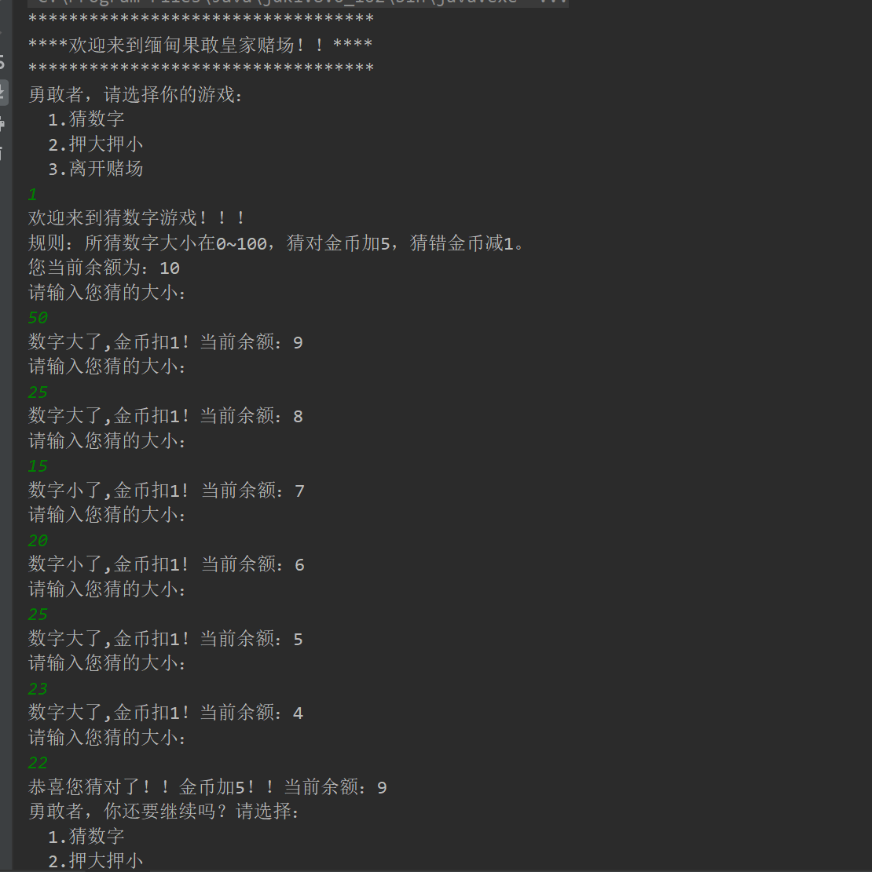

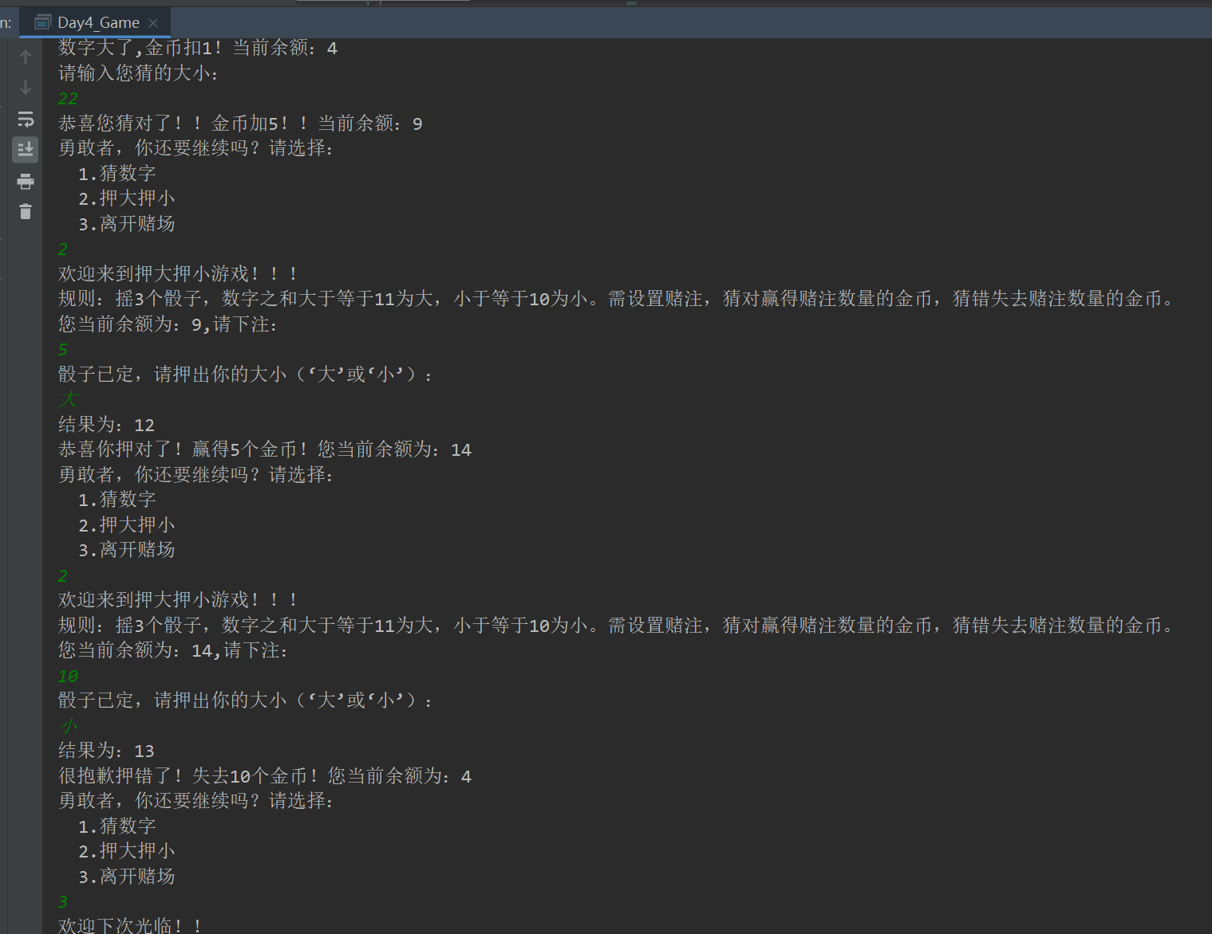

2.用户列表项目的结果如下

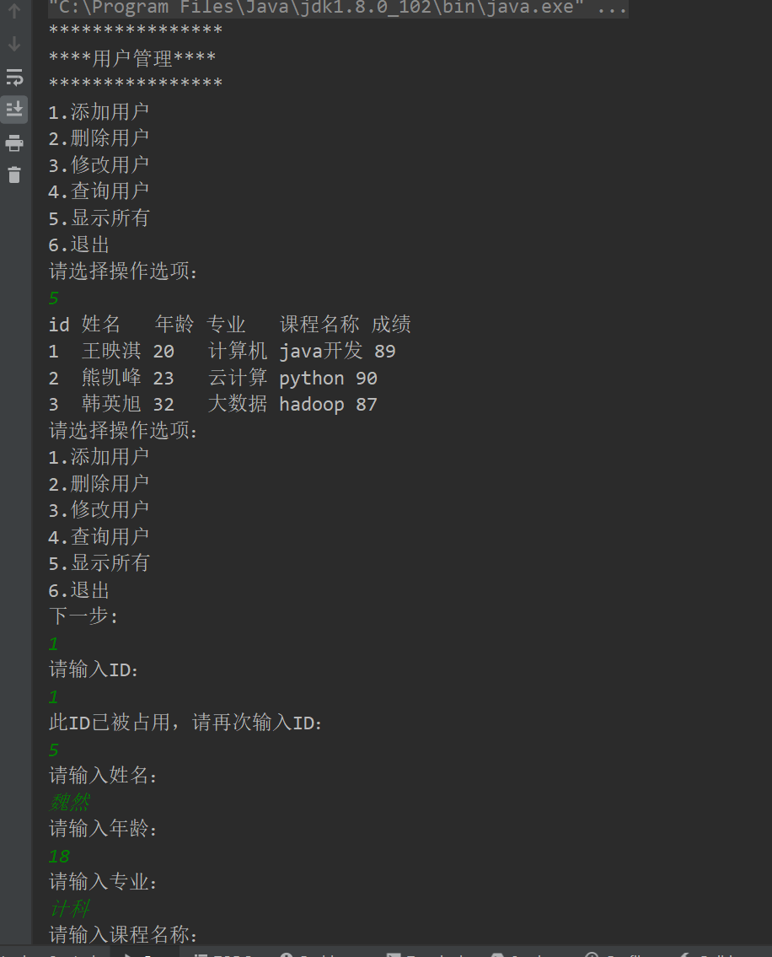

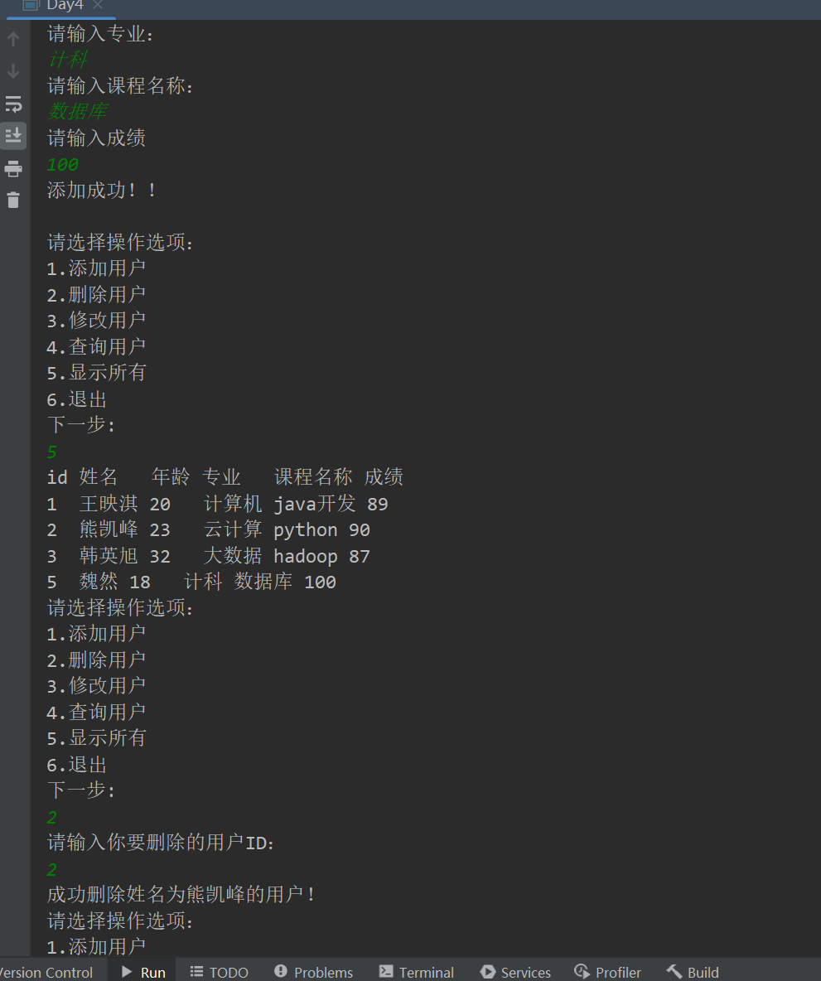

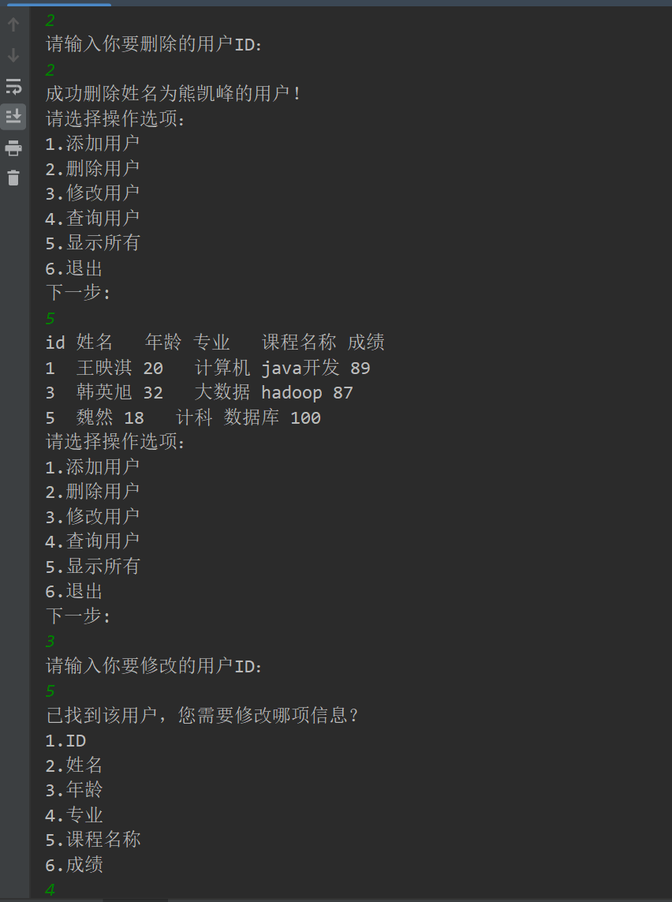

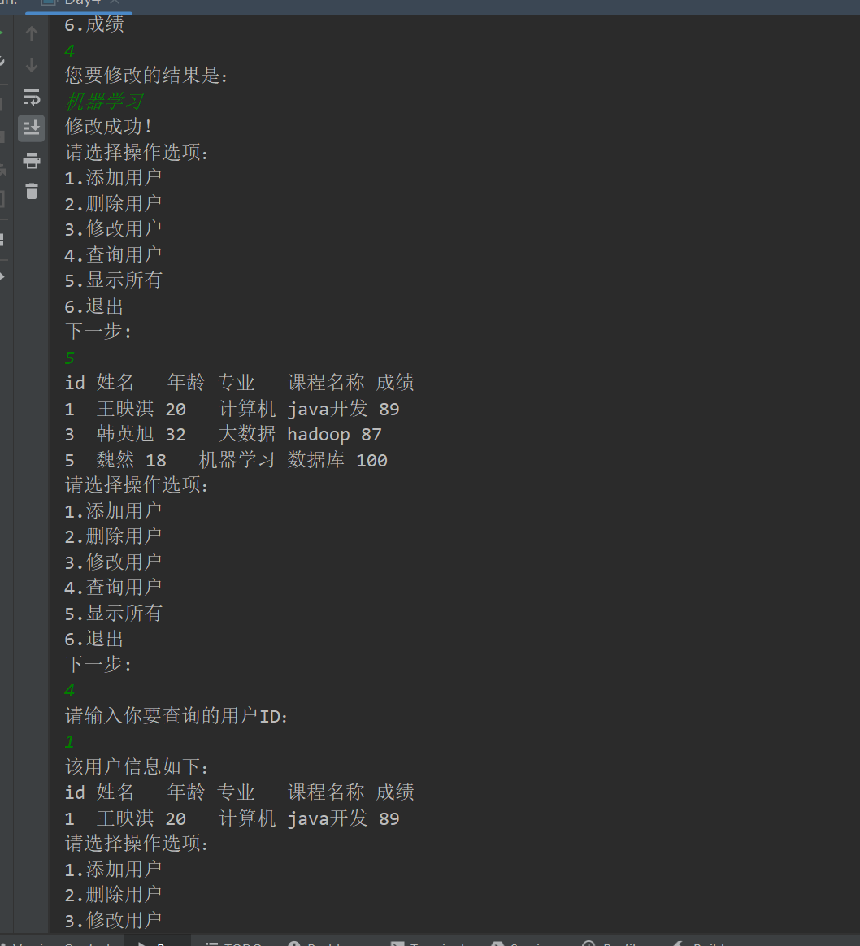

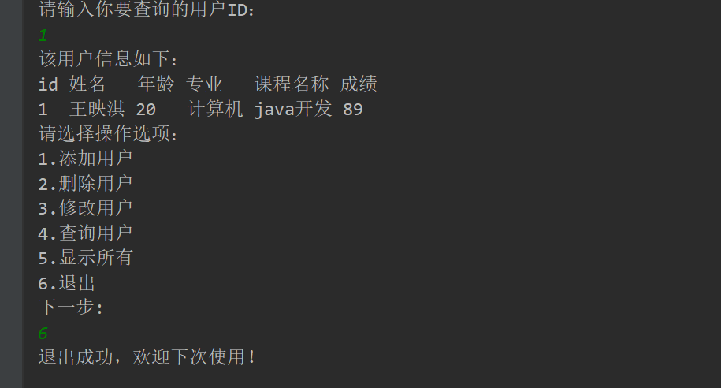

**赌场游戏的代码如下：**

import java.util.Random;

import java.util.Scanner;

public class Day4_Game {

public static void main(String[] args) {

int money=10;

int opt=0;

Scanner sca=new Scanner(System.in);

welcome();

while(true)

{

opt=sca.nextInt();

if(opt==3)

{

System.out.println("欢迎下次光临！！");

break;

}

else if (opt==1)

{

money=guessNum(money);

}

else if (opt==2)

{

money=betBS(money);

}

else System.out.println("很抱歉，指令错误");

contin();

}

}

//猜数字

public static int guessNum(int money) {

Random ran=new Random();

Scanner sca=new Scanner(System.in);

int num=ran.nextInt(100);

int guess=-1;

System.out.println("欢迎来到猜数字游戏！！！");

System.out.println("规则：所猜数字大小在0~100，猜对金币加5，猜错金币减1。");

System.out.println("您当前余额为："+money);

while(guess!=num)

{

System.out.println("请输入您猜的大小：");

guess=sca.nextInt();

if(guess>num)

{

money--;

System.out.println("数字大了,金币扣1！当前余额："+money);

}

else if(guess<num)

{

money--;

System.out.println("数字小了,金币扣1! 当前余额："+money);

}

else

{

money=money+5;

System.out.println("恭喜您猜对了！！金币加5！！当前余额："+money);

}

}

return money;

}

//押大押小

public static int betBS(int money) {

Random ran=new Random();

int sum= ran.nextInt(6)+ran.nextInt(6)+ran.nextInt(6)+3;

Scanner sca=new Scanner(System.in);

System.out.println("欢迎来到押大押小游戏！！！");

System.out.println("规则：摇3个骰子，数字之和大于等于11为大，小于等于10为小。需设置赌注，猜对赢得赌注数量的金币，猜错失去赌注数量的金币。");

System.out.println("您当前余额为："+money+",请下注：");

int bats=sca.nextInt();

System.out.println("骰子已定，请押出你的大小（‘大’或‘小’）：");

String guess=sca.next();

System.out.println("结果为："+sum);

if(sum>=11)

{

if(guess.equals("大"))

{

money+=bats;

System.out.println("恭喜你押对了！赢得"+bats+"个金币！您当前余额为："+money);

}

else if (guess.equals("小"))

{

money-=bats;

System.out.println("很抱歉押错了！失去"+bats+"个金币！您当前余额为："+money);

}

else System.out.println("出错了！请联系工作人员");

}

else if(sum<=10)

{

if(guess.equals("小"))

{

money+=bats;

System.out.println("恭喜你押对了！赢得"+bats+"个金币！您当前余额为："+money);

}

else if (guess.equals("大"))

{

money-=bats;

System.out.println("很抱歉押错了！失去"+bats+"个金币！您当前余额为："+money);

}

else System.out.println("出错了！请联系工作人员");

}

else System.out.println("出错了！请联系工作人员");

return money;

}

//欢迎词

public static void welcome() {

System.out.println("**********************************");

System.out.println("****欢迎来到缅甸果敢皇家赌场！！****");

System.out.println("**********************************");

System.out.println("勇敢者，请选择你的游戏：");

System.out.println(" 1.猜数字");

System.out.println(" 2.押大押小");

System.out.println(" 3.离开赌场");

}

//是否继续

public static void contin() {

System.out.println("勇敢者，你还要继续吗？请选择：");

System.out.println(" 1.猜数字");

System.out.println(" 2.押大押小");

System.out.println(" 3.离开赌场");

}

}

**用户列表的代码如下**

import java.util.ArrayList;  
import java.util.Scanner;  
  
public class Day4 {  
 static int *num*=3;  
 public static void main(String[] args) {  
 ArrayList<Student> students=new ArrayList<Student>();  
 students.add(new Student(1,"王映淇",20,"计算机","java开发",89));  
 students.add(new Student(2,"熊凯峰",23,"云计算","python",90));  
 students.add(new Student(3,"韩英旭",32,"大数据","hadoop",87));  
 int opt=0;  
 Scanner sca=new Scanner(System.*in*);  
 *welcome*();  
 while(true)  
 {  
 opt=sca.nextInt();  
 if(opt==6)  
 {  
 *exit*();  
 break;  
 }  
 else if (opt==1)  
 {  
 *addStudent*(students);  
 }  
 else if (opt==2)  
 {  
 *deleteStudent*(students);  
 }  
 else if (opt==3)  
 {  
 *changeStudent*(students);  
 }  
 else if (opt==4)  
 {  
 *inquireStudent*(students);  
 }  
 else if (opt==5)  
 {  
 *showAll*(students);  
 }  
 else System.*out*.println("很抱歉，指令错误");  
 *contin*();  
 }  
 }  
  
 public static void welcome() {  
 System.*out*.println("****************");  
 System.*out*.println("****用户管理****");  
 System.*out*.println("****************");  
 System.*out*.println("1.添加用户");  
 System.*out*.println("2.删除用户");  
 System.*out*.println("3.修改用户");  
 System.*out*.println("4.查询用户");  
 System.*out*.println("5.显示所有");  
 System.*out*.println("6.退出");  
 System.*out*.println("请选择操作选项：");  
 }  
  
 public static void addStudent(ArrayList<Student> students) {  
 int id= *num*++;  
 String name;  
 int age;  
 String major;  
 String classname;  
 int grade;  
 Scanner sca=new Scanner(System.*in*);  
  
 System.*out*.println("请输入ID：");  
 id=sca.nextInt();  
 while(*idJudge*(students,id))  
 {  
 System.*out*.println("此ID已被占用，请再次输入ID：");  
 id=sca.nextInt();  
 }  
 System.*out*.println("请输入姓名：");  
 name=sca.next();  
 System.*out*.println("请输入年龄：");  
 age=sca.nextInt();  
 System.*out*.println("请输入专业：");  
 major= sca.next();  
 System.*out*.println("请输入课程名称：");  
 classname=sca.next();  
 System.*out*.println("请输入成绩");  
 grade=sca.nextInt();  
  
 students.add(new Student(id,name,age,major,classname,grade));  
 System.*out*.println("添加成功！！\n");  
 }  
  
 public static void deleteStudent(ArrayList<Student> students) {  
 Scanner sca=new Scanner(System.*in*);  
 *num*--;  
 int deleteId;  
 int obj=-1;  
 System.*out*.println("请输入你要删除的用户ID：");  
 deleteId= sca.nextInt();  
 for(int i=0;i<students.size();i++)  
 {  
 if(students.get(i).getId()==deleteId)obj=i;  
 }  
  
 if(obj==-1)  
 {  
 System.*out*.println("未找到该ID用户，操作失败");  
 }  
 else {  
 String name=students.get(obj).getName();  
 students.remove(obj);  
 System.*out*.println("成功删除姓名为"+name+"的用户！");  
 }  
  
 }  
  
 public static void changeStudent(ArrayList<Student> students) {  
 Scanner sca=new Scanner(System.*in*);  
 System.*out*.println("请输入你要修改的用户ID：");  
 int changeId=sca.nextInt();  
 int obj=-1;  
 for(int i=0;i<students.size();i++)  
 {  
 if(students.get(i).getId()==changeId)obj=i;  
 }  
 if(obj==-1)  
 {  
 System.*out*.println("未找到该用户，操作失败");  
 }  
 else  
 {  
 System.*out*.println("已找到该用户，您需要修改哪项信息？");  
 System.*out*.println("1.ID");  
 System.*out*.println("2.姓名");  
 System.*out*.println("3.年龄");  
 System.*out*.println("4.专业");  
 System.*out*.println("5.课程名称");  
 System.*out*.println("6.成绩");  
 int opt= sca.nextInt();  
 switch (opt)  
 {  
 case 1:  
 System.*out*.println("您要修改的结果是：");  
 int id=sca.nextInt();  
 while(*idJudge*(students,id))  
 {  
 System.*out*.println("此ID已被占用，请再次输入：");  
 id=sca.nextInt();  
 }  
 students.get(obj).setId(id);  
 System.*out*.println("修改成功！");  
 break;  
 case 2:  
 System.*out*.println("您要修改的结果是：");  
 String name=sca.next();  
 students.get(obj).setName(name);  
 System.*out*.println("修改成功！");  
 break;  
 case 3:  
 System.*out*.println("您要修改的结果是：");  
 int age=sca.nextInt();  
 students.get(obj).setAge(age);  
 System.*out*.println("修改成功！");  
 break;  
 case 4:  
 System.*out*.println("您要修改的结果是：");  
 String major=sca.next();  
 students.get(obj).setMajor(major);  
 System.*out*.println("修改成功！");  
 break;  
 case 5:  
 System.*out*.println("您要修改的结果是：");  
 String classname=sca.next();  
 students.get(obj).setClassname(classname);  
 System.*out*.println("修改成功！");  
 break;  
 case 6:  
 System.*out*.println("您要修改的结果是：");  
 int grade=sca.nextInt();  
 students.get(obj).setGrade(grade);  
 System.*out*.println("修改成功！");  
 break;  
 default:  
 System.*out*.println("未有该选项，操作失败");  
 }  
 }  
 }  
  
 public static void inquireStudent(ArrayList<Student> students) {  
 Scanner sca=new Scanner(System.*in*);  
 System.*out*.println("请输入你要查询的用户ID：");  
 int inquireId=sca.nextInt();  
 int obj=-1;  
 for(int i=0;i<students.size();i++)  
 {  
 if(students.get(i).getId()==inquireId)obj=i;  
 }  
 if(obj==-1)  
 {  
 System.*out*.println("未找到该用户，操作失败");  
 }  
 else  
 {  
 System.*out*.println("该用户信息如下：");  
 System.*out*.println("id 姓名 年龄 专业 课程名称 成绩");  
 System.*out*.println(students.get(obj).getId()+" "+students.get(obj).getName()+" "+students.get(obj).getAge()+" "+students.get(obj).getMajor()+" "+students.get(obj).getClassname()+" "+students.get(obj).getGrade());  
 }  
  
 }  
  
 public static void showAll(ArrayList<Student> students) {  
 System.*out*.println("id 姓名 年龄 专业 课程名称 成绩");  
 for(int i=0;i<students.size();i++)  
 {  
 System.*out*.println(students.get(i).getId()+" "+students.get(i).getName()+" "+students.get(i).getAge()+" "+students.get(i).getMajor()+" "+students.get(i).getClassname()+" "+students.get(i).getGrade());  
 }  
 }  
  
 public static void exit() {  
 System.*out*.println("退出成功，欢迎下次使用！");  
 }  
  
 public static void contin() {  
 System.*out*.println("请选择操作选项：");  
 System.*out*.println("1.添加用户");  
 System.*out*.println("2.删除用户");  
 System.*out*.println("3.修改用户");  
 System.*out*.println("4.查询用户");  
 System.*out*.println("5.显示所有");  
 System.*out*.println("6.退出");  
 System.*out*.println("下一步: ");  
  
 }  
  
 public static boolean idJudge(ArrayList<Student> students,int idd) {  
 for(int i=0;i<students.size();i++)  
 {  
 if(students.get(i).getId()==idd)return true;  
 }  
 return false;  
 }  
  
}

public class Student {  
 private int id;  
 private String name;  
 private int age;  
 private String major;  
 private String classname;  
 private int grade;  
  
 public Student(int id,String name,int age, String major,String classname,int grade)  
 {  
 this.id=id;  
 this.name=name;  
 this.age=age;  
 this.major=major;  
 this.classname=classname;  
 this.grade=grade;  
 }  
  
 public int getId() {  
 return id;  
 }  
  
 public String getName() {  
 return name;  
 }  
  
 public int getAge() {  
 return age;  
 }  
  
 public String getMajor() {  
 return major;  
 }  
  
 public String getClassname() {  
 return classname;  
 }  
  
 public int getGrade() {  
 return grade;  
 }  
  
 public void setId(int id) {  
 this.id = id;  
 }  
  
 public void setName(String name) {  
 this.name = name;  
 }  
  
 public void setAge(int age) {  
 this.age = age;  
 }  
  
 public void setMajor(String major) {  
 this.major = major;  
 }  
  
 public void setClassname(String classname) {  
 this.classname = classname;  
 }  
  
 public void setGrade(int grade) {  
 this.grade = grade;  
 }  
}

**彭尹垚**

Java日志

今天学习了在类中封装变量和方法

类中不同修饰的变量和函数，类的构造函数

String的不同用法，作为基础数据类型与作为类来使用

字符串一旦创建后永不改变，判断字符串地址相等用“==”，而判断值相等用的是“equal”

其余实现了两个小项目，在实现项目的过程中了解了static修饰的成员函数的差异与用法

了解了arrlist<> 容器的一些用法。学习了随机数生成器random的基础用法

猜数游戏

代码

选择游戏部分

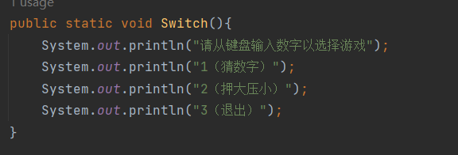

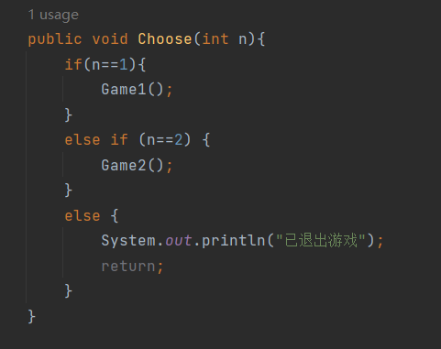

游戏1

金币部分（能存储）

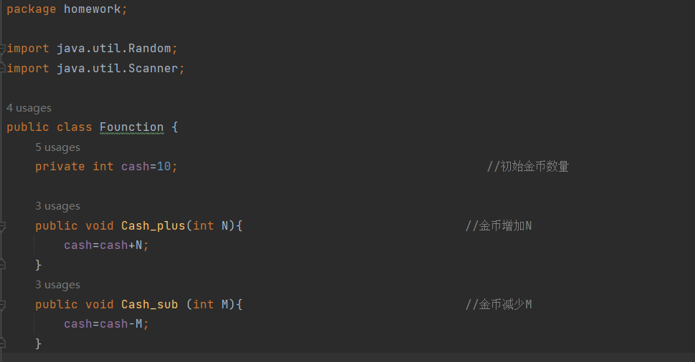

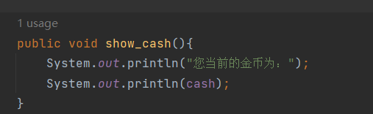

主体部分

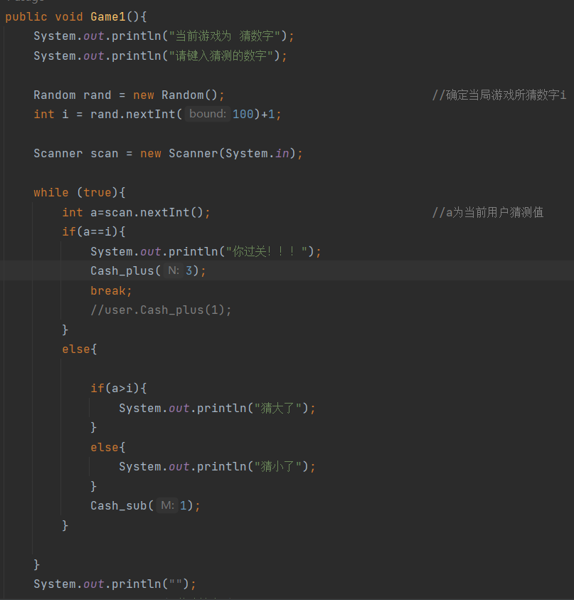

游戏2

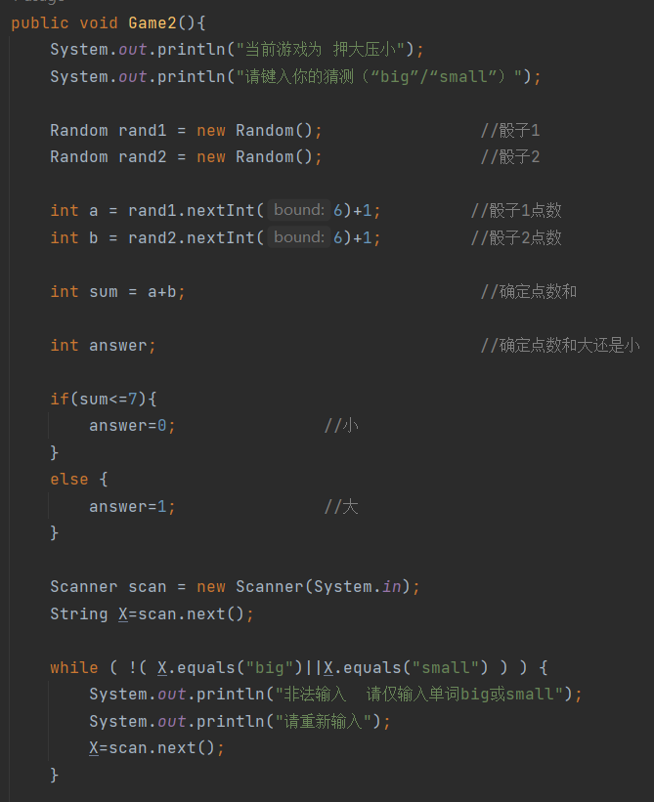

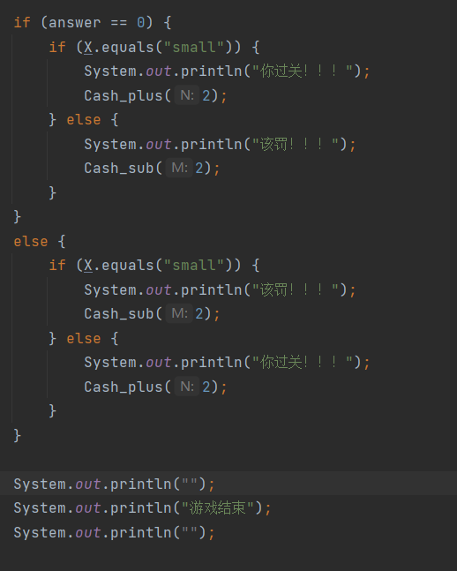

实现效果：

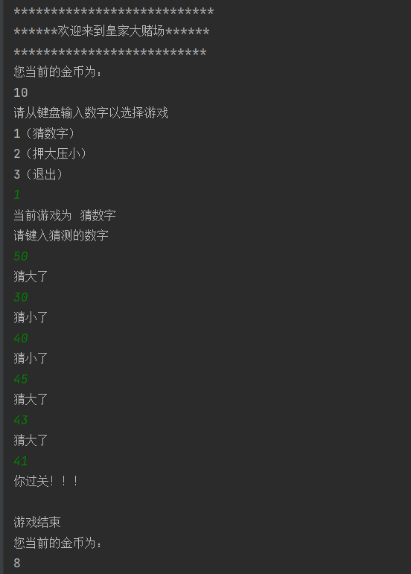

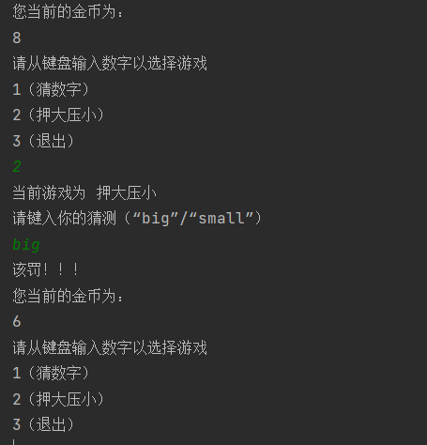

学生管理系统：

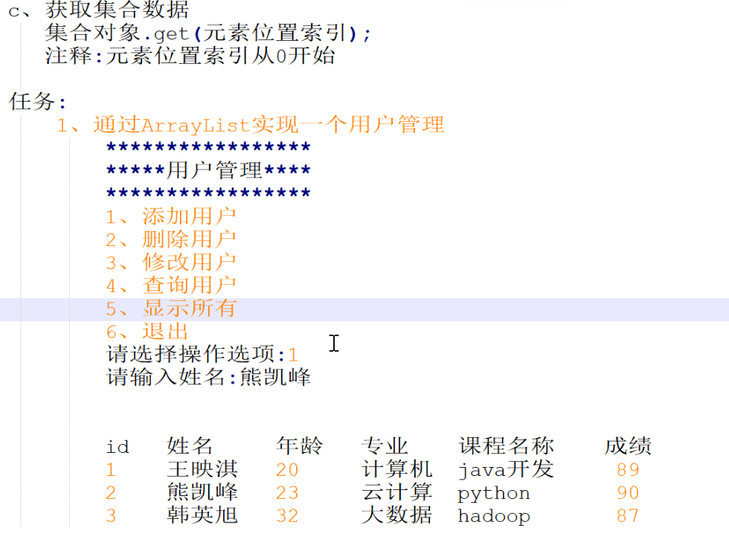

用户类（Function）：

基础数据及构造函数：

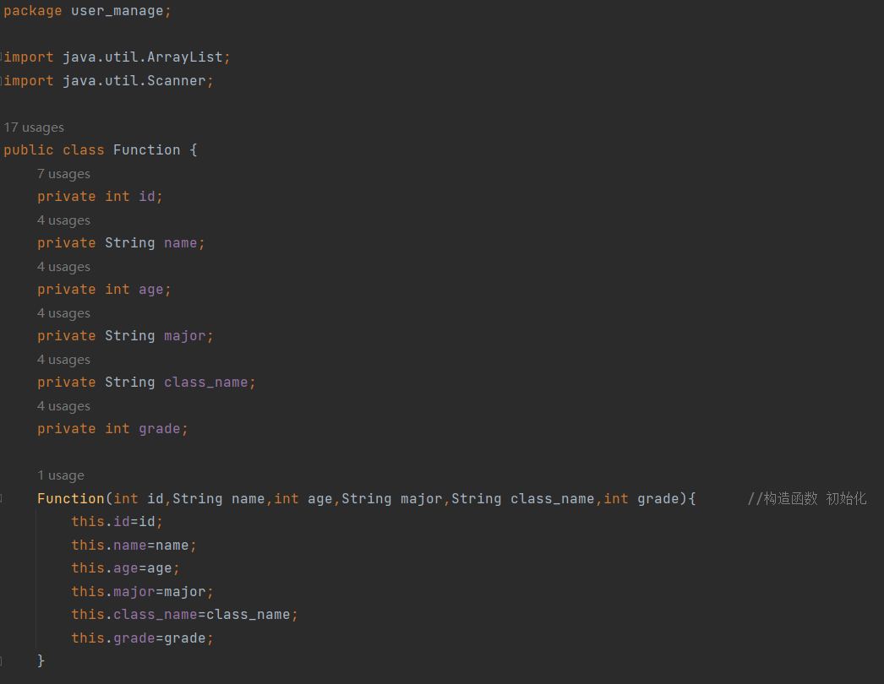

1. 添加用户

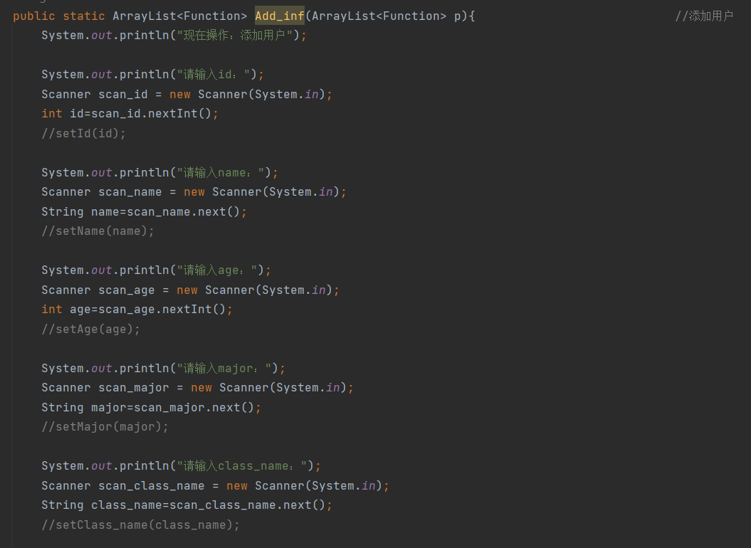

1. 删除用户

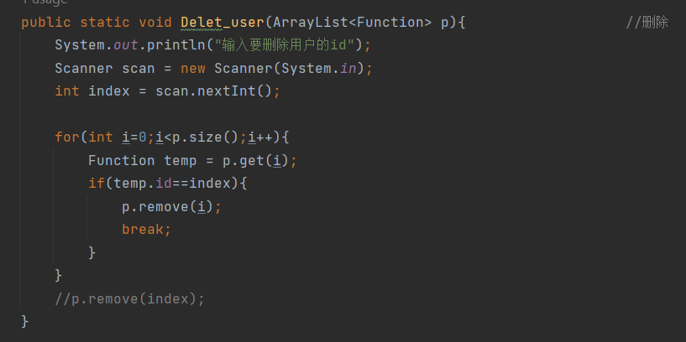

3、修改值（目前仅支持修改成绩）

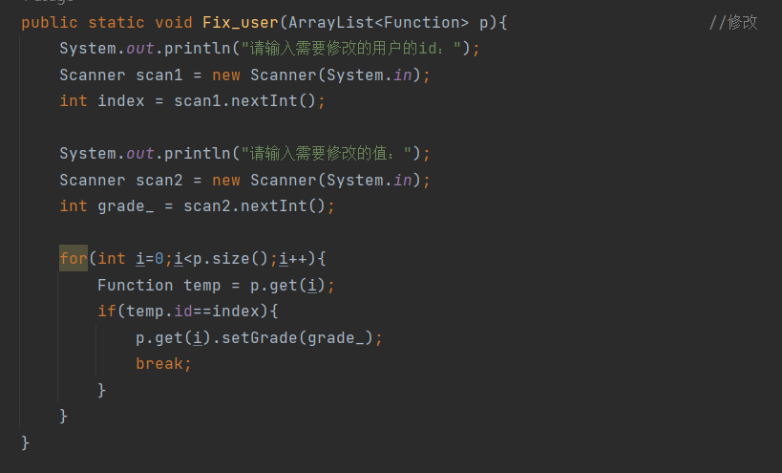

4、查询用户数据

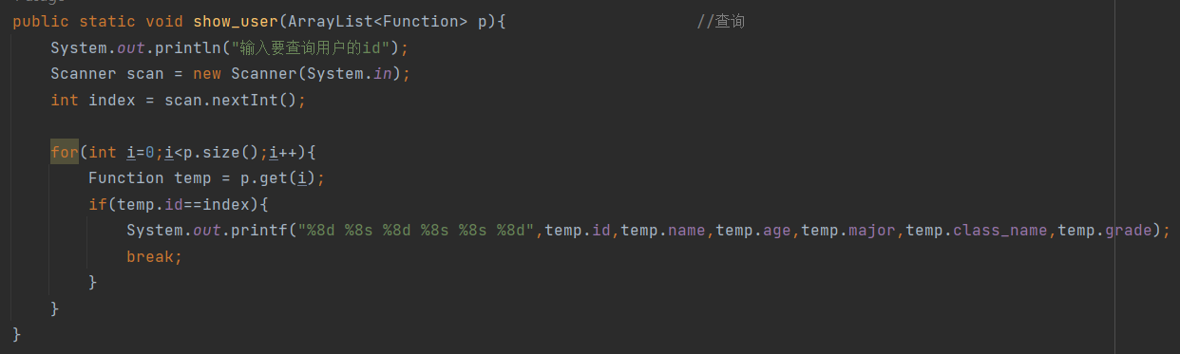

1. 遍历所有用户数据

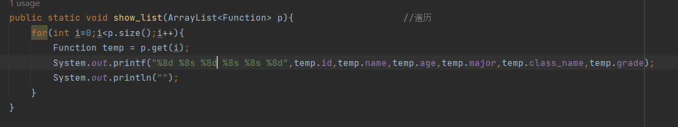

选择部分

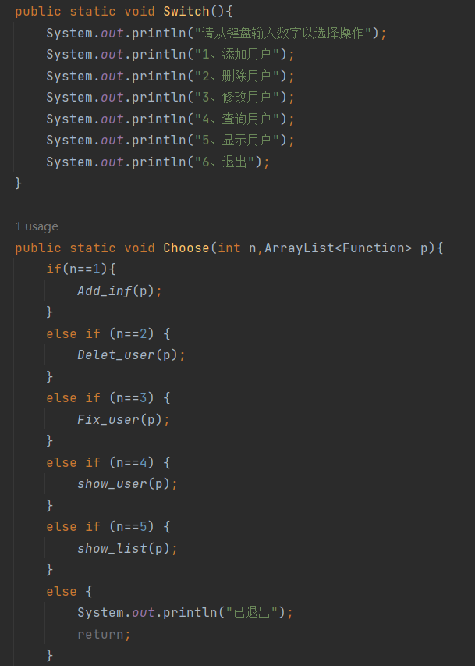

主函数：

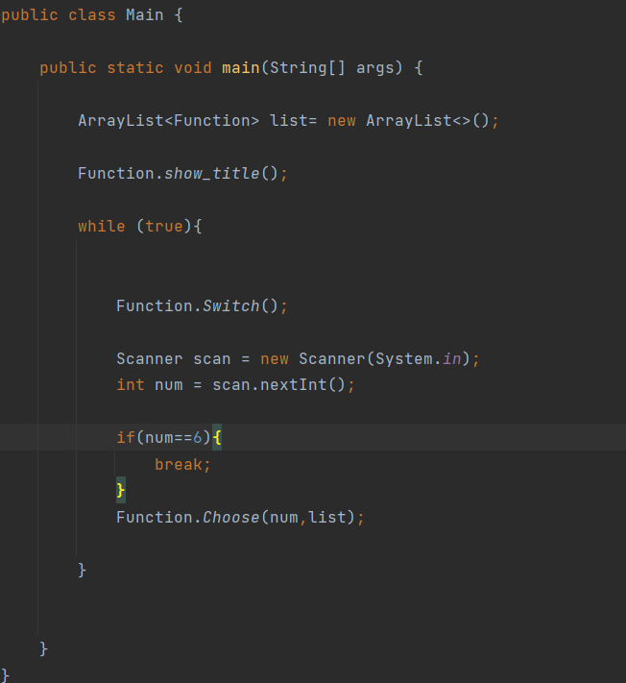

实现效果：

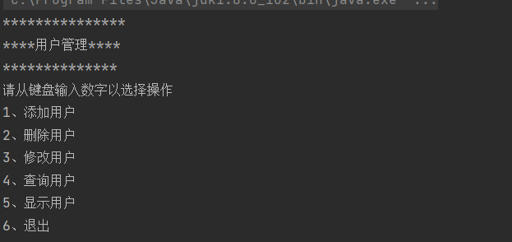

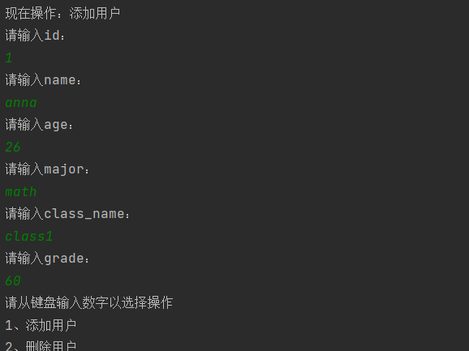

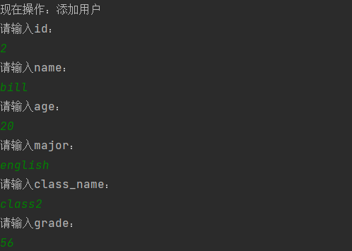

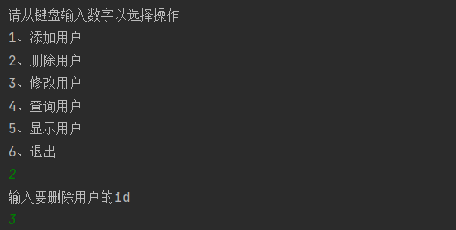

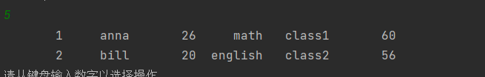



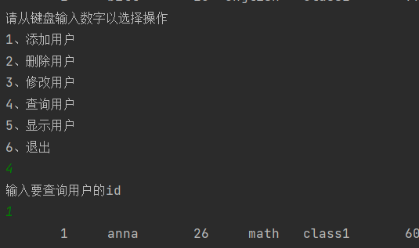

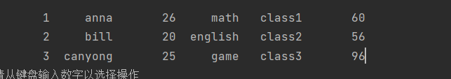

**谢泽川**

##### Java学习日志 - JAVA程序的编写和集合的编写与应用

##### 日期：2024年8月17日

##### 学习内容：

学习了JAVA程序的编写和集合的编写与应用

任务一：

游戏的编写：

界面设置代码

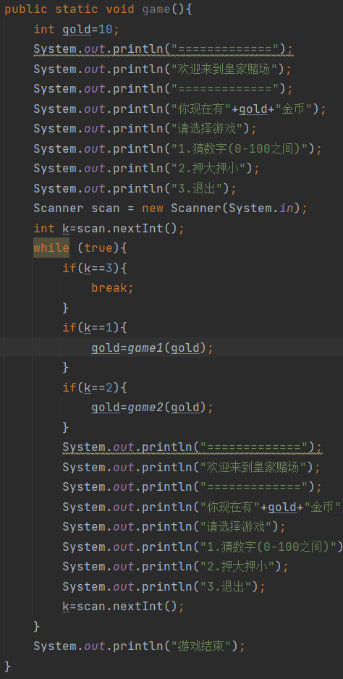

猜大小：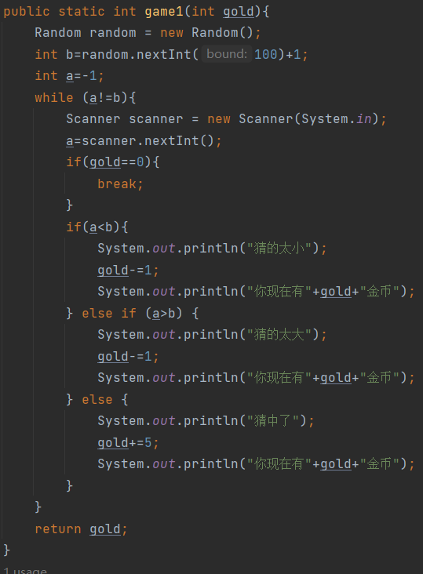

押大押小：

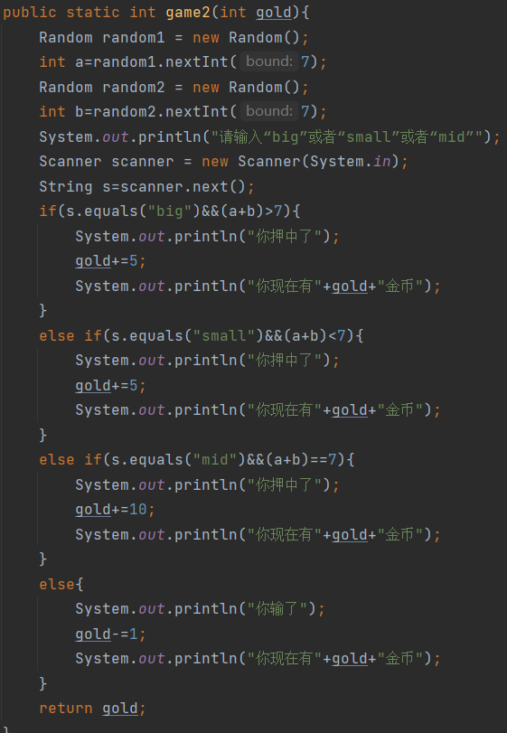

结果：

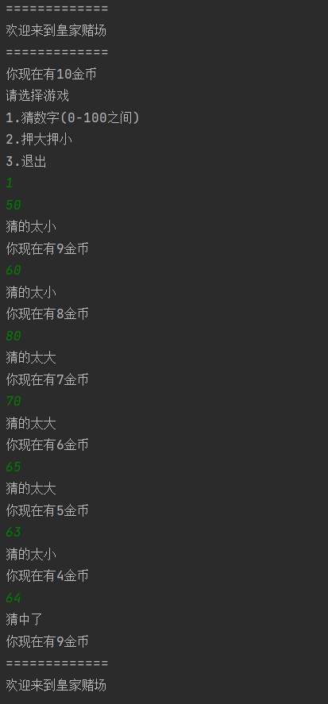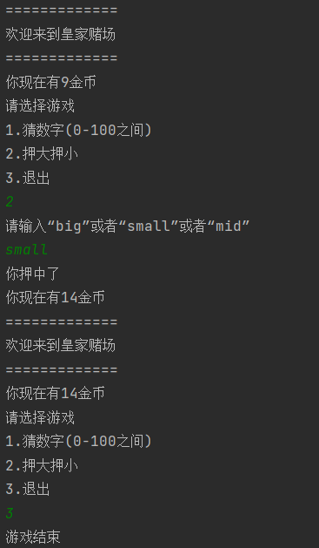

任务二：

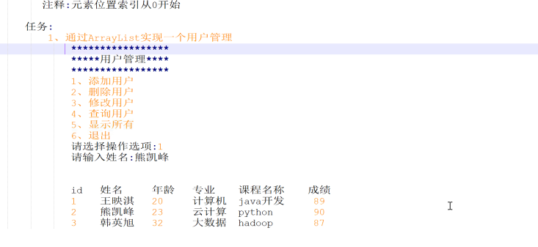

界面设置：

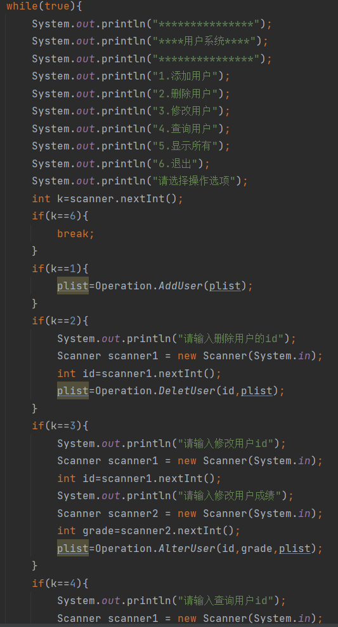

添加用户：

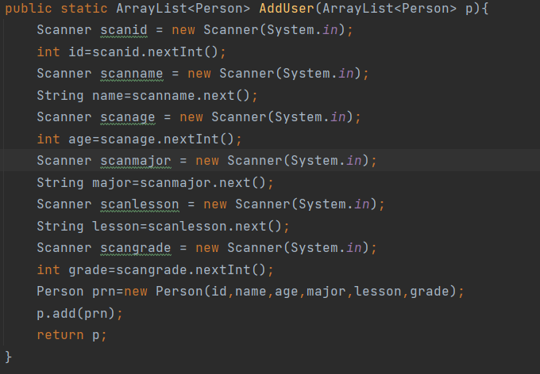

删除用户：

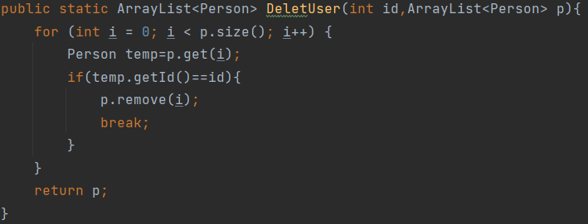

修改用户：

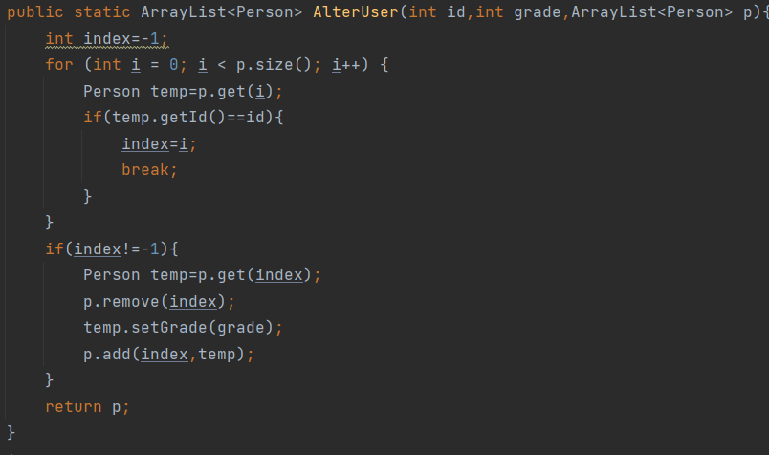

查询用户：

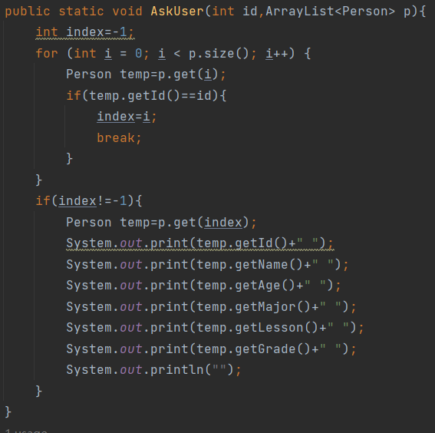

显示所有：

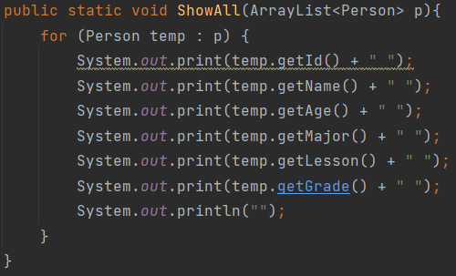

结果展示：

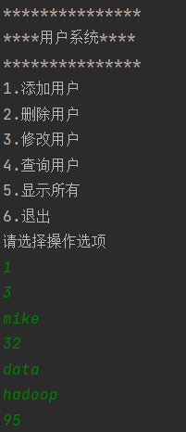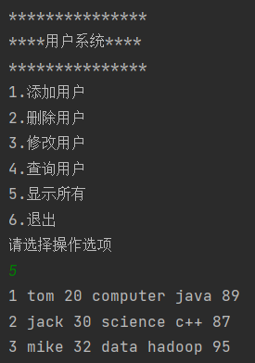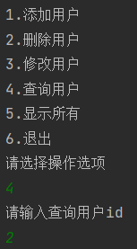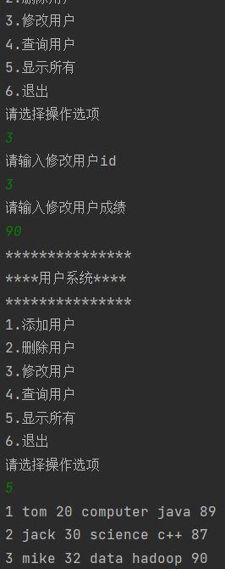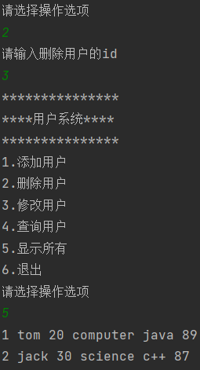

**张世纪**

上午两题：

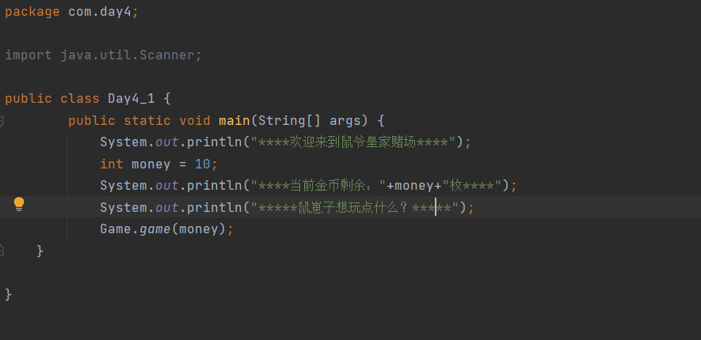

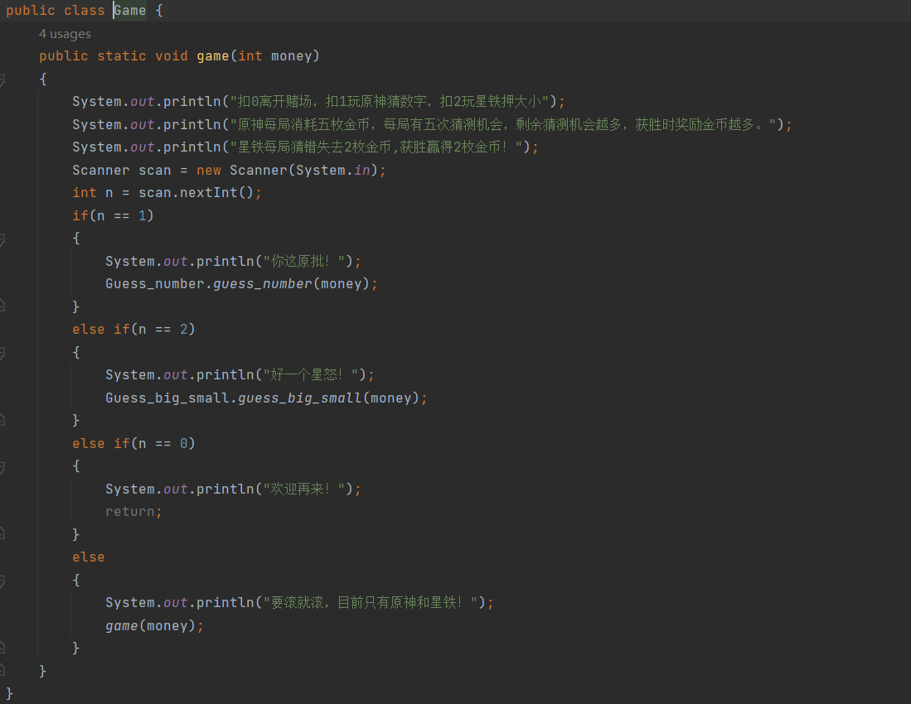

猜数字：

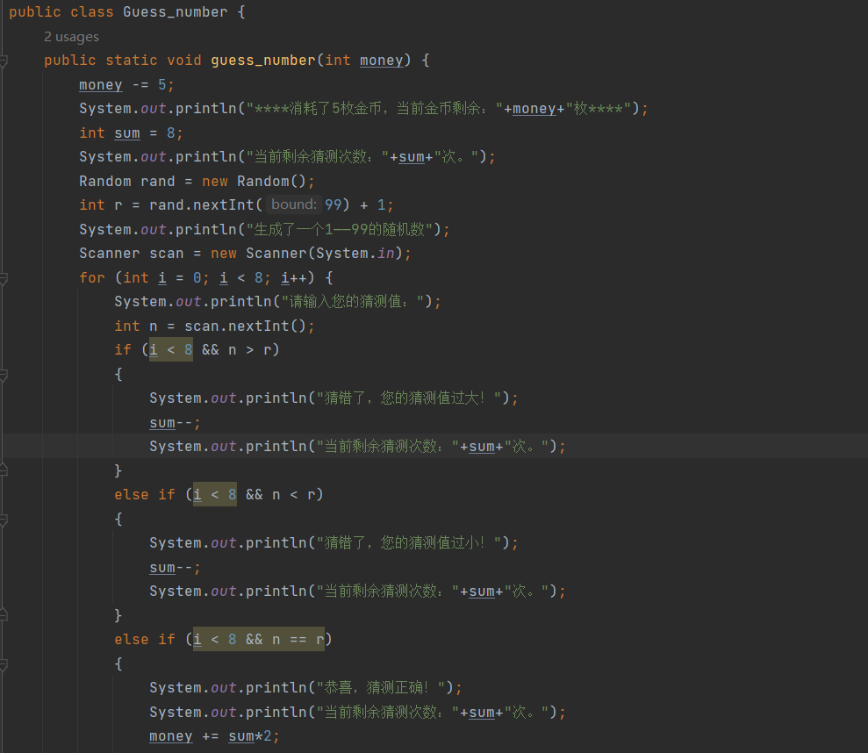

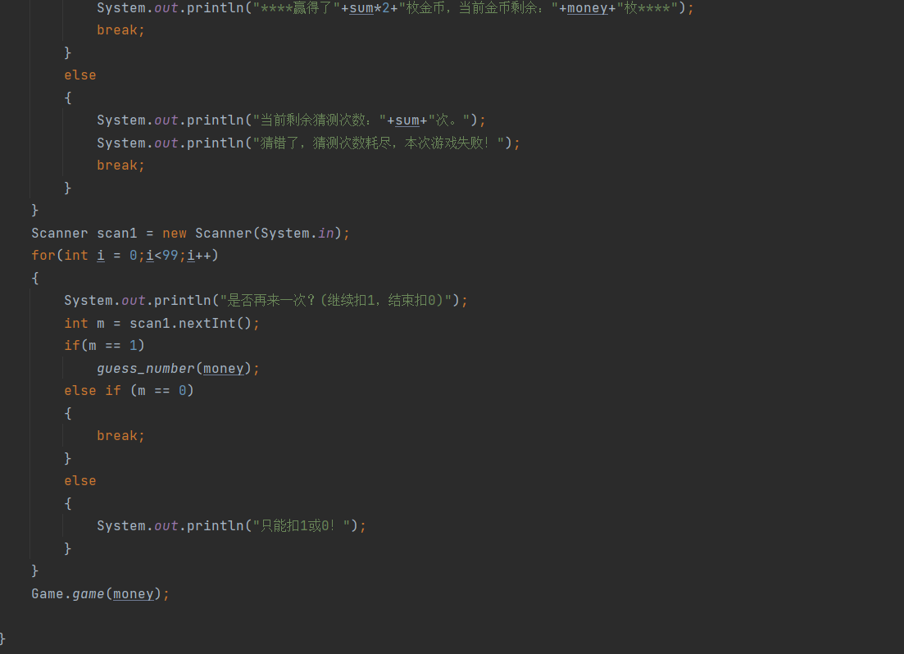

押大小：

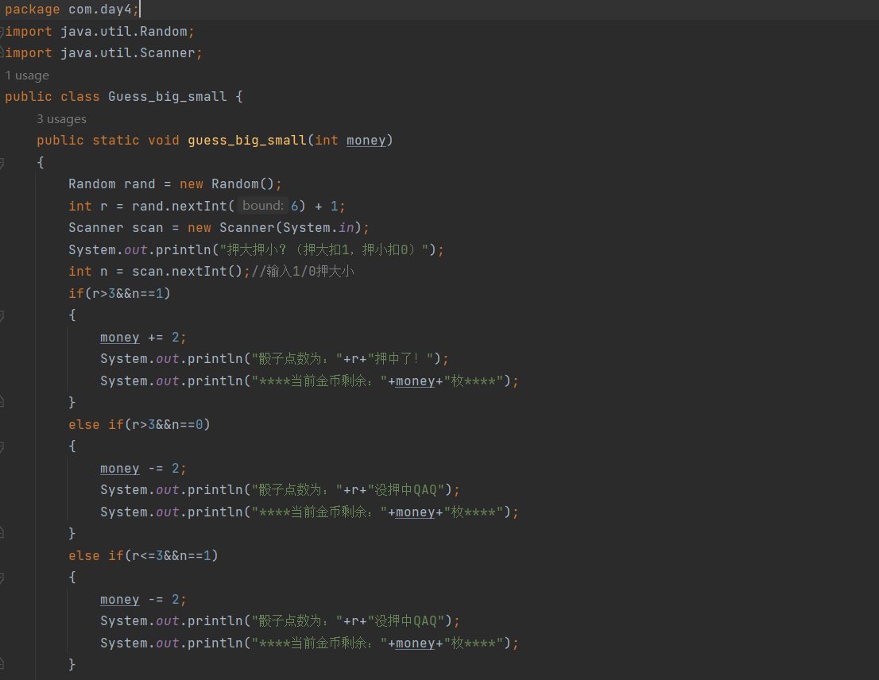

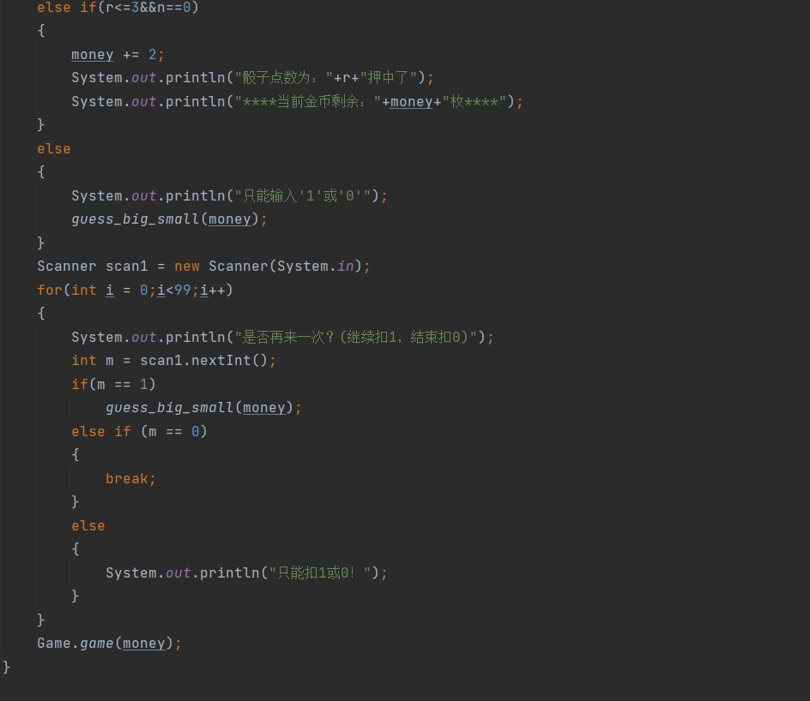

运行结果：

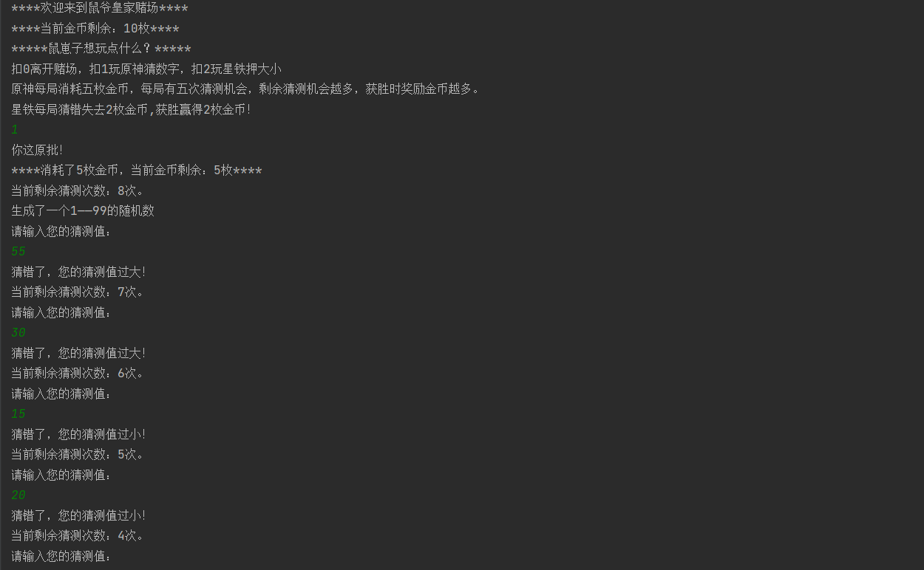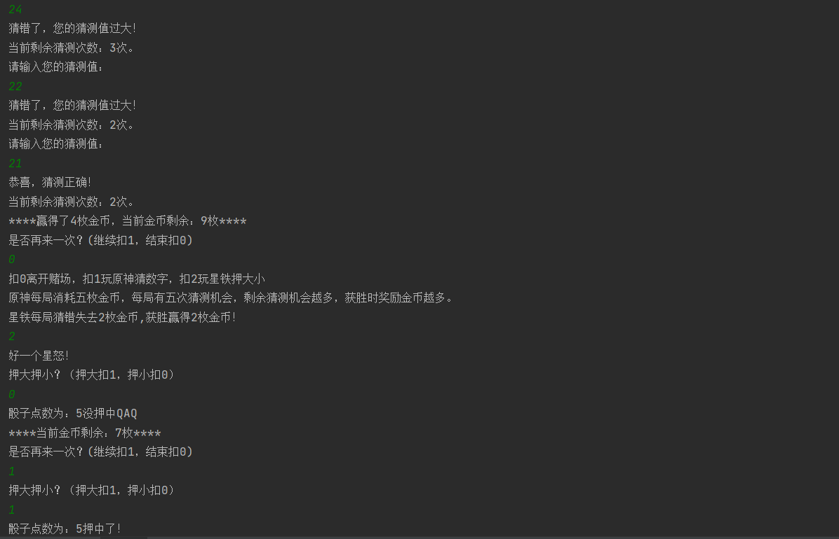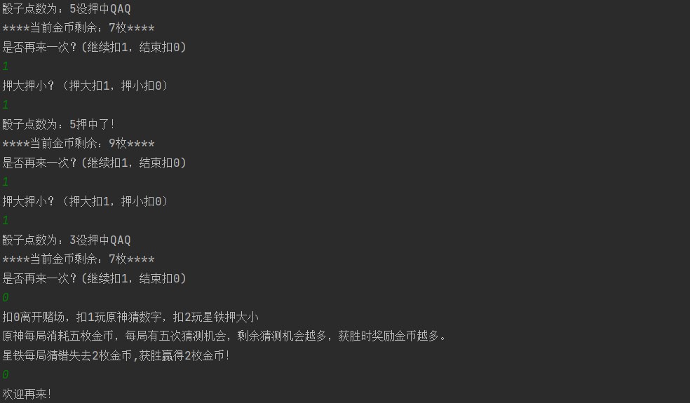

下午一题：

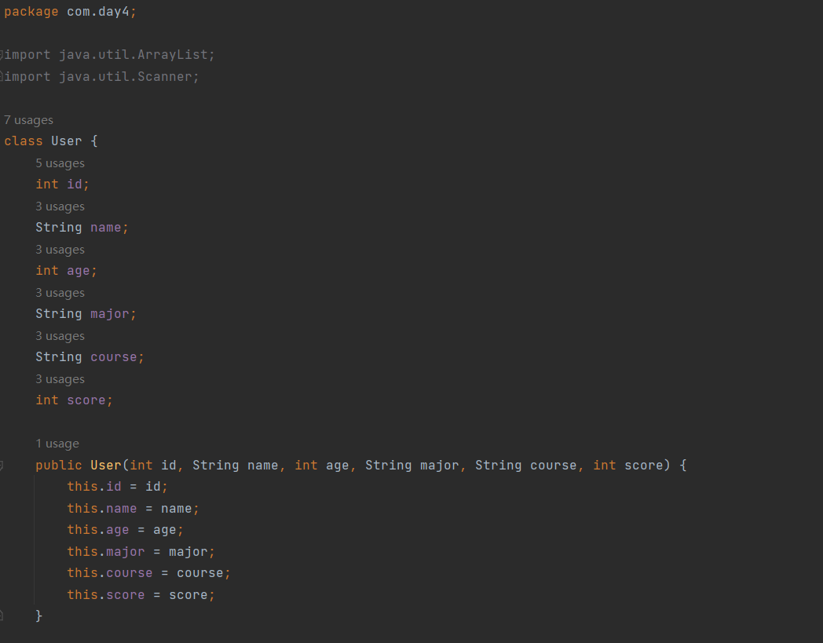

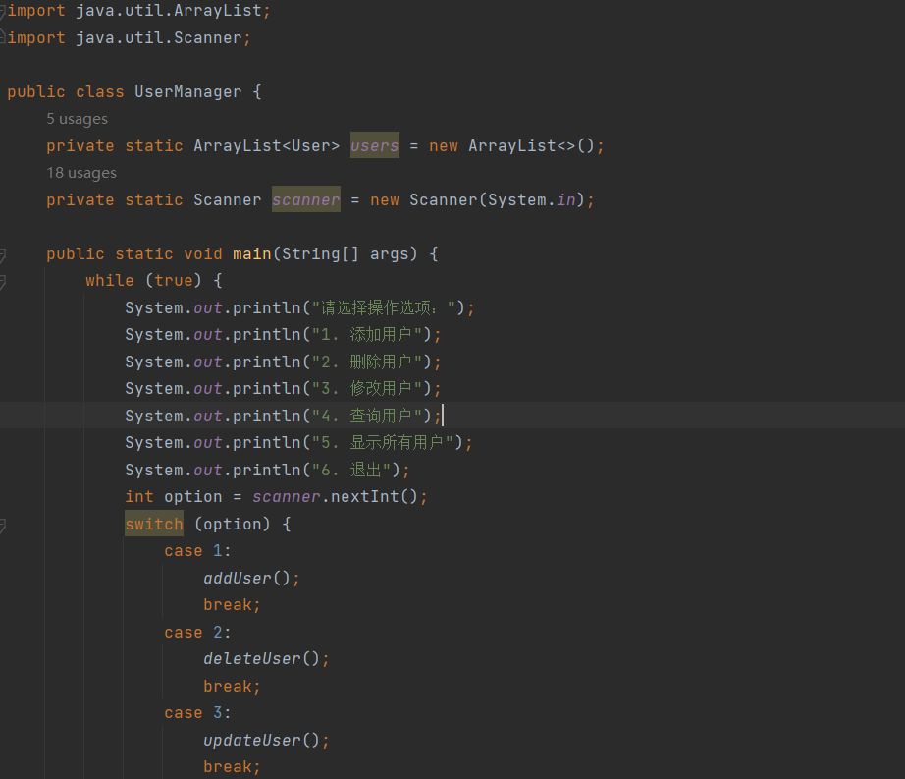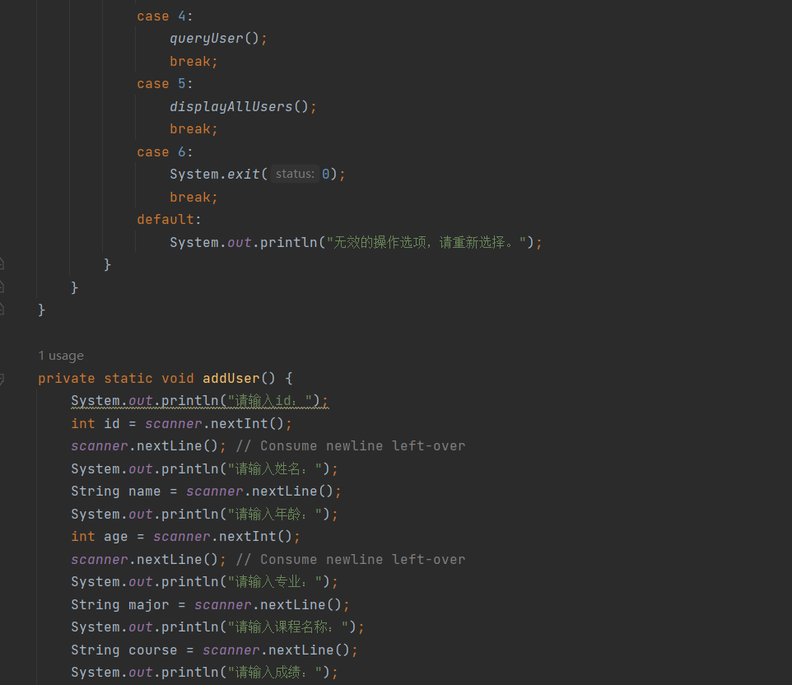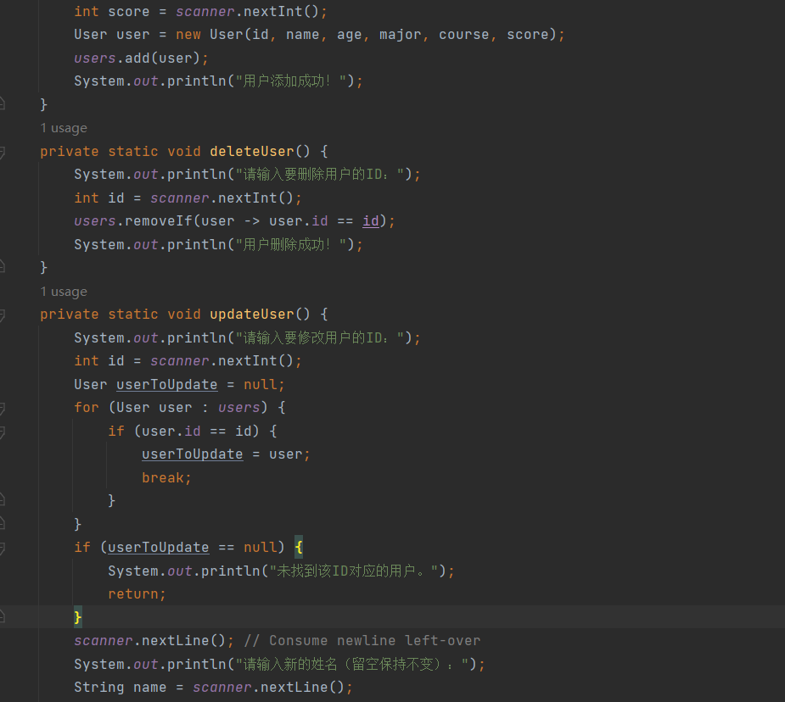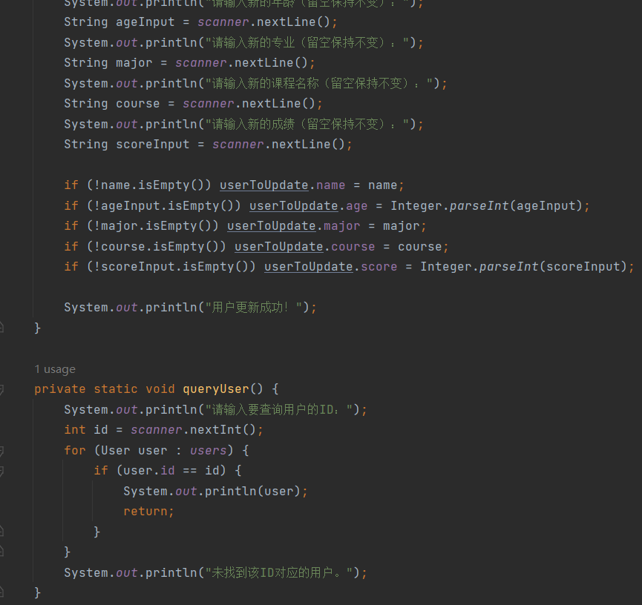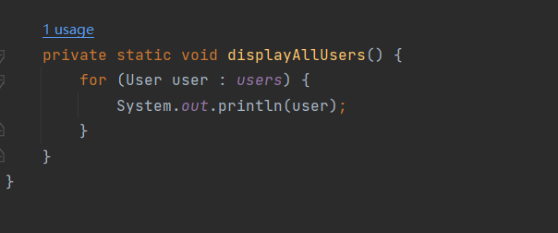

运行结果：

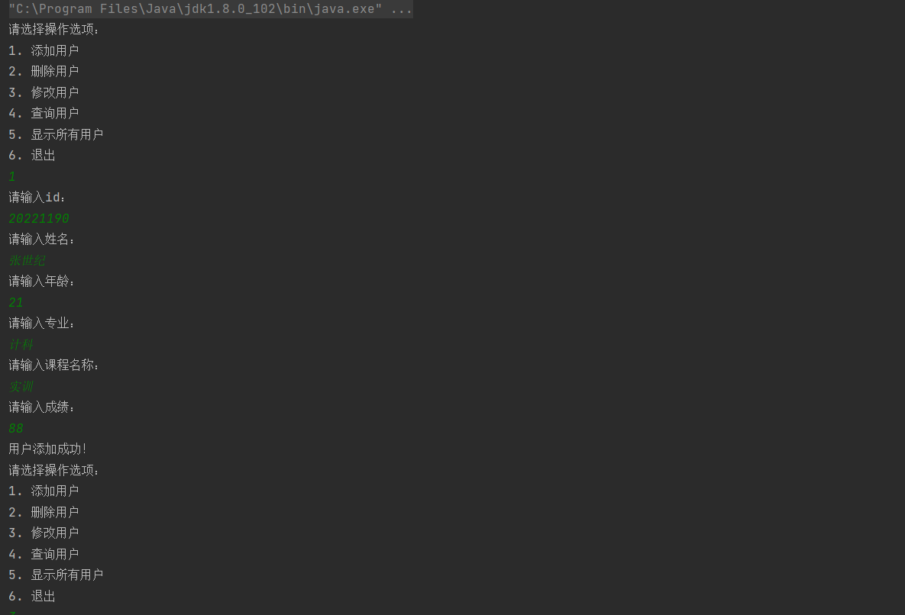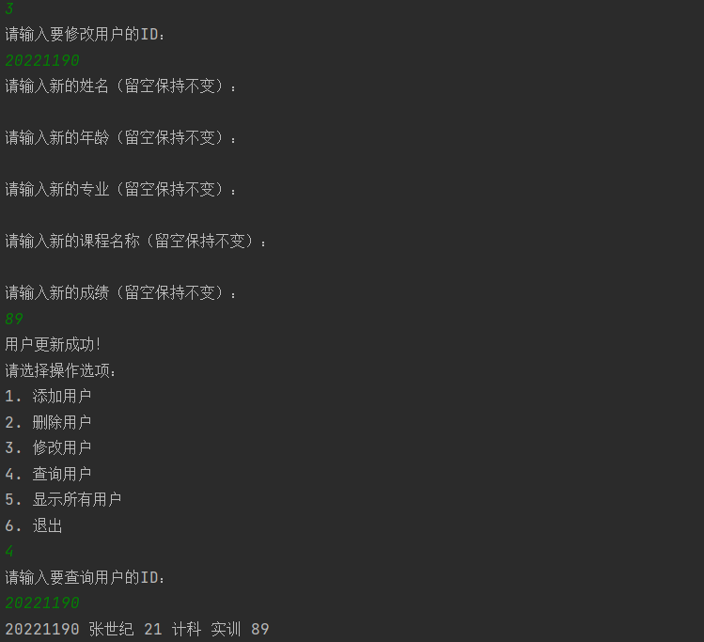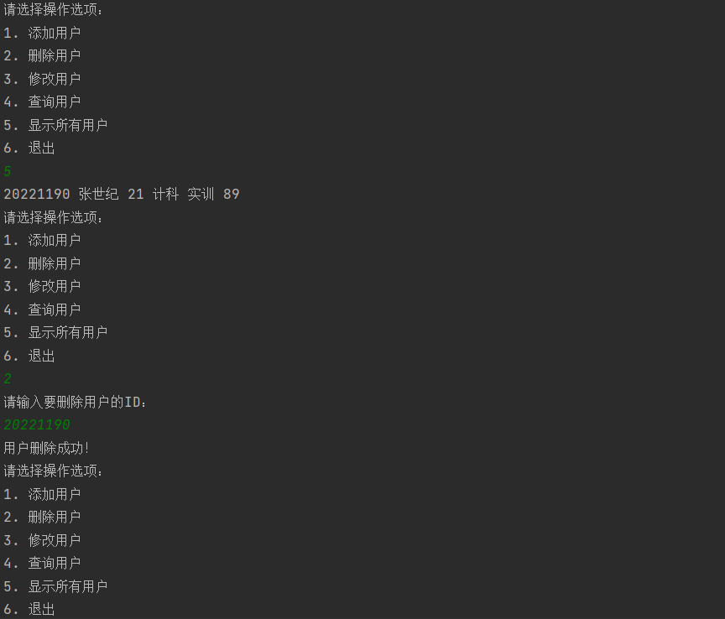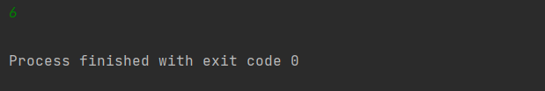

**叶翔昊**

8·18实训日志

总体情况：任务全部完成，问题顺利解决。学习了面向对象构造函数，以及使用ArrayList完成任务。对JAVA代码的编写更加了解和熟悉。

任务一：

皇家赌场，猜数字，押大押小。

完成情况：顺利完成，学习了switch的用法以及随机数和输入的代码编写。

代码：

package com.cq.cd.studnt;  
  
import java.util.Random;  
import java.util.Scanner;  
  
public class test {  
 private static int *coin* = 100;  
 public static void main(String[] args) {  
 while (true) {  
 System.*out*.println("=====================");  
 System.*out*.println("====欢迎来到皇家赌场====");  
 System.*out*.println("=====================");  
 System.*out*.println("请选择游戏:");  
 System.*out*.println("1、猜数字");  
 System.*out*.println("2、押大押小");  
 System.*out*.println("3、退出");  
 System.*out*.println("你目前的金币余额为:" + *coin*);  
 Scanner scan = new Scanner(System.*in*); // 创建Scanner对象  
  
 int choice = scan.nextInt();  
  
  
 switch (choice) {  
 case 1:  
 *playGuessingGame*();  
 break;  
 case 2:  
 *playHighLowGame*();  
 break;  
 case 3:  
 System.*out*.println("即将退出赌场，欢迎下次再来！");  
 scan.close();  
 return; // 退出 main 方法，结束程序  
 default:  
 System.*out*.println("抱歉，这是无效的输入喔，请再次输入！");  
 break;  
 }  
 }  
 }  
 public static void playGuessingGame() {  
 System.*out*.println("100以内猜数字游戏现在开始！");  
 Scanner scan = new Scanner(System.*in*);  
 Random rand = new Random();  
 int targetNumber = rand.nextInt(100) + 1;  
 int guess = 0;  
 int attempts = 0;  
  
 int playcoin = 0;  
 while (true) {  
  
 System.*out*.println("请输入你想投入的金币数（投入越多回报越多！）");  
 playcoin = scan.nextInt();  
 if (playcoin > *coin*) {  
 System.*out*.println("金币不足，请重试！");  
  
 }  
 else if (playcoin < 0) {  
 System.*out*.println("投入金币不能为负数，请重试！");  
  
 } else {  
 break;  
 }  
  
 }  
 System.*out*.println("请输入你的猜测");  
 while (guess != targetNumber) {  
  
 guess = scan.nextInt();  
 attempts++;  
  
 if (guess < targetNumber) {  
 System.*out*.println("小小小小小小！猜的数字太小啦！请再试一次:)");  
 } else if (guess > targetNumber) {  
 System.*out*.println("大大大大大大！猜的数字太大啦！请再试一次:)");  
 } else if (guess == targetNumber) {  
 System.*out*.println("恭喜！猜中数字啦！答案就是:" + targetNumber);  
 }  
 }  
 if (attempts == 1 && attempts == 2) {  
 System.*out*.println("你用了" + attempts + "次就猜对啦，请问你是在作弊吗？");  
 *coin* = *coin* + 5 * playcoin;  
 System.*out*.println("奖励5倍投入金币！你的金币余额为:" + *coin*);  
 } else if (3 < attempts && attempts <= 6) {  
 System.*out*.println("你用了" + attempts + "次就猜对啦，太厉害啦，你是猜数字高手！");  
 *coin* = *coin* + 3 * playcoin;  
 System.*out*.println("奖励3倍投入金币！你的金币余额为:" + *coin*);  
 } else if (6 < attempts && attempts <= 7) {  
 System.*out*.println("你用了" + attempts + "次就猜对啦，正常人水平！");  
 *coin* = *coin*+playcoin;  
 System.*out*.println("奖励1倍投入金币！你的金币余额为:" + *coin*);  
 } else if (7 < attempts && attempts <= 9) {  
 System.*out*.println("你用了" + attempts + "次就猜对啦，加油！你会越来越厉害的！");  
 *coin* = *coin* - playcoin;  
 System.*out*.println("没收投入金币！继续加油吧！你的金币余额为:" + *coin*);  
 } else if (9 < attempts) {  
 System.*out*.println("你用了" + attempts + "次就猜对啦，加油，有些技巧可以帮助你更快猜到喔！");  
 *coin* = *coin* - 2 * playcoin;  
 System.*out*.println("没收2倍投入金币！继续加油吧！你的金币余额为:" + *coin*);  
 }  
 }  
 public static void playHighLowGame() {  
 System.*out*.println("押大押小游戏现在开始！");  
 Scanner scan = new Scanner(System.*in*);  
 Random rand = new Random();  
 int Highlownumber1 = rand.nextInt(6) + 1;  
 int Highlownumber2 =rand.nextInt(6) + 1;  
 int Highlownumber=Highlownumber1+Highlownumber2;  
 int playcoin = 0;  
 while (true) {  
  
 System.*out*.println("请输入你想投入的金币数（投入越多回报越多！）");  
 playcoin = scan.nextInt();  
 if (playcoin > *coin*) {  
 System.*out*.println("金币不足，请重试！");  
  
 }  
 else if (playcoin < 0) {  
 System.*out*.println("投入金币不能为负数，请重试！");  
  
 } else {  
 break;  
 }  
  
 }  
 System.*out*.println("请问你要押大还是押小？"+"\n"+"1、大"+"\n"+"2、小");  
 int num=scan.nextInt();  
  
 if(Highlownumber>8&&num==1){  
 System.*out*.println("是大大大！恭喜你押对了！");  
 System.*out*.println("获得2倍投入金币!");  
 *coin*=*coin*+2*playcoin;  
 } else if (Highlownumber<5&&num==2) {  
 System.*out*.println("是小小小！恭喜你押对了！");  
 System.*out*.println("获得2倍投入金币!");  
 *coin*=*coin*+2*playcoin;  
 }  
 else{  
 System.*out*.println("抱歉，你押错了！><");  
 System.*out*.println("没收一倍投入金币！");  
 *coin*=*coin*-2*playcoin;  
 }  
  
 }  
  
}

运行情况：

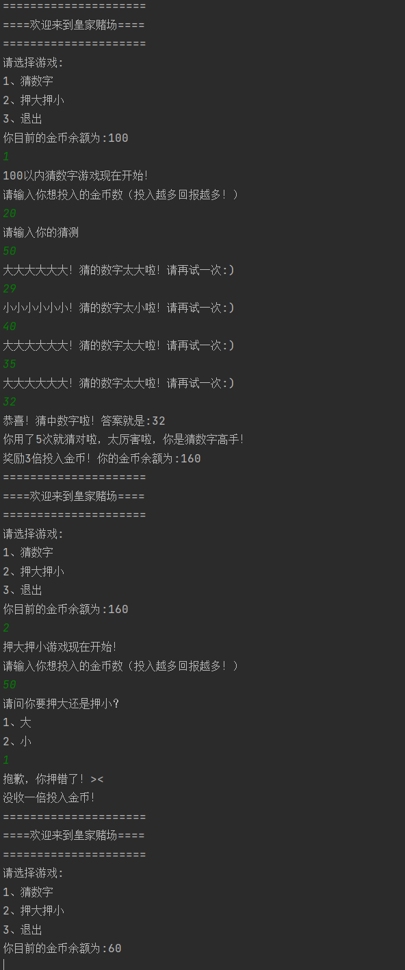

任务二：ArrayList完成学生信息管理系统

完成情况：顺利完成，学习了ArrayList的用法以及对类的声明和编写。

代码：

package ArrayList;  
  
public class User {  
 private int id;  
 private String name;  
 private int age;  
 private String major;  
 private int grade;  
 private String course; // 更新字段名  
  
 public User(int id, String name, int age, String major, int grade, String course) {  
 this.id = id;  
 this.name = name;  
 this.age = age;  
 this.major = major;  
 this.grade = grade;  
 this.course = course; // 初始化课程字段  
 }  
  
 public int getId() {  
 return id;  
 }  
  
 public String getName() {  
 return name;  
 }  
  
 public void setName(String name) {  
 this.name = name;  
 }  
  
 public int getAge() {  
 return age;  
 }  
  
 public void setAge(int age) {  
 this.age = age;  
 }  
  
 public String getMajor() {  
 return major;  
 }  
  
 public void setMajor(String major) {  
 this.major = major;  
 }  
  
 public int getGrade() {  
 return grade;  
 }  
  
 public void setGrade(int grade) {  
 this.grade = grade;  
 }  
  
 public String getCourse() {  
 return course;  
 }  
  
 public void setCourse(String course) {  
 this.course = course;  
 }  
  
 @Override  
 public String toString() {  
 return String.*format*("ID: %d, 姓名: %s, 年龄: %d, 专业: %s, 成绩: %d, 课程: %s", id, name, age, major, grade, course);  
 }  
}

package ArrayList;  
  
import java.util.ArrayList;  
import java.util.Scanner;  
  
public class UserManager {  
 private ArrayList<User> users = new ArrayList<>();  
 private int nextId = 1;  
  
 public static void main(String[] args) {  
 UserManager um = new UserManager();  
 Scanner scanner = new Scanner(System.*in*);  
  
 while (true) {  
 System.*out*.println("用户管理系统");  
 System.*out*.println("1、添加用户");  
 System.*out*.println("2、删除用户");  
 System.*out*.println("3、修改用户");  
 System.*out*.println("4、查询用户");  
 System.*out*.println("5、显示所有用户");  
 System.*out*.println("6、退出");  
  
 System.*out*.print("请选择操作选项: ");  
 int choice = scanner.nextInt();  
 scanner.nextLine(); // 读取换行符  
  
 switch (choice) {  
 case 1:  
 um.addUser(scanner);  
 break;  
 case 2:  
 um.deleteUser(scanner);  
 break;  
 case 3:  
 um.modifyUser(scanner);  
 break;  
 case 4:  
 um.queryUser(scanner);  
 break;  
 case 5:  
 um.displayAllUsers();  
 break;  
 case 6:  
 System.*out*.println("退出系统");  
 scanner.close();  
 return;  
 default:  
 System.*out*.println("无效的选项，请重新选择");  
 break;  
 }  
 }  
 }  
  
 public void addUser(Scanner scanner) {  
 System.*out*.print("请输入姓名: ");  
 String name = scanner.nextLine();  
 System.*out*.print("请输入年龄: ");  
 int age = scanner.nextInt();  
 scanner.nextLine(); // 读取换行符  
 System.*out*.print("请输入专业名称: ");  
 String major = scanner.nextLine();  
 System.*out*.print("请输入课程名称: ");  
 String course = scanner.nextLine();  
 System.*out*.print("请输入成绩: ");  
 int grade = scanner.nextInt();  
 scanner.nextLine(); // 读取换行符  
  
 User user = new User(nextId++, name, age, major, grade, course);  
 users.add(user);  
 System.*out*.println("用户添加成功!");  
 }  
  
 public void deleteUser(Scanner scanner) {  
 System.*out*.print("请输入要删除的用户ID: ");  
 int id = scanner.nextInt();  
 scanner.nextLine(); // 读取换行符  
  
 User userToRemove = null;  
 for (User user : users) {  
 if (user.getId() == id) {  
 userToRemove = user;  
 break;  
 }  
 }  
  
 if (userToRemove != null) {  
 users.remove(userToRemove);  
 System.*out*.println("用户删除成功!");  
 } else {  
 System.*out*.println("未找到ID为" + id + "的用户");  
 }  
 }  
  
 public void modifyUser(Scanner scanner) {  
 System.*out*.print("请输入要修改的用户ID: ");  
 int id = scanner.nextInt();  
 scanner.nextLine(); // 读取换行符  
  
 User userToModify = null;  
 for (User user : users) {  
 if (user.getId() == id) {  
 userToModify = user;  
 break;  
 }  
 }  
  
 if (userToModify != null) {  
 System.*out*.print("请输入新的姓名(当前: " + userToModify.getName() + "): ");  
 String name = scanner.nextLine();  
 System.*out*.print("请输入新的年龄(当前: " + userToModify.getAge() + "): ");  
 int age = scanner.nextInt();  
 scanner.nextLine(); // 读取换行符  
 System.*out*.print("请输入新的专业名称(当前: " + userToModify.getMajor() + "): ");  
 String major = scanner.nextLine();  
 System.*out*.print("请输入新的课程名称(当前: " + userToModify.getCourse() + "): ");  
 String course = scanner.nextLine();  
 System.*out*.print("请输入新的成绩(当前: " + userToModify.getGrade() + "): ");  
 int grade = scanner.nextInt();  
 scanner.nextLine(); // 读取换行符  
  
 userToModify.setName(name);  
 userToModify.setAge(age);  
 userToModify.setMajor(major);  
 userToModify.setCourse(course);  
 userToModify.setGrade(grade);  
  
 System.*out*.println("用户信息修改成功!");  
 } else {  
 System.*out*.println("未找到ID为" + id + "的用户");  
 }  
 }  
  
 public void queryUser(Scanner scanner) {  
 System.*out*.print("请输入要查询的用户ID: ");  
 int id = scanner.nextInt();  
 scanner.nextLine(); // 读取换行符  
  
 User userToQuery = null;  
 for (User user : users) {  
 if (user.getId() == id) {  
 userToQuery = user;  
 break;  
 }  
 }  
  
 if (userToQuery != null) {  
 System.*out*.println("查询结果: " + userToQuery);  
 } else {  
 System.*out*.println("未找到ID为" + id + "的用户");  
 }  
 }  
  
 public void displayAllUsers() {  
 System.*out*.printf("%-3s %-5s %-3s %-10s %-10s %-3s%n", "ID", "姓名", "年龄", "专业", "课程", "成绩");  
 for (User user : users) {  
 System.*out*.printf("%-3d %-5s %-3d %-10s %-10s %-3d%n", user.getId(), user.getName(), user.getAge(), user.getMajor(), user.getCourse(), user.getGrade());  
 }  
 }  
}

运行情况：

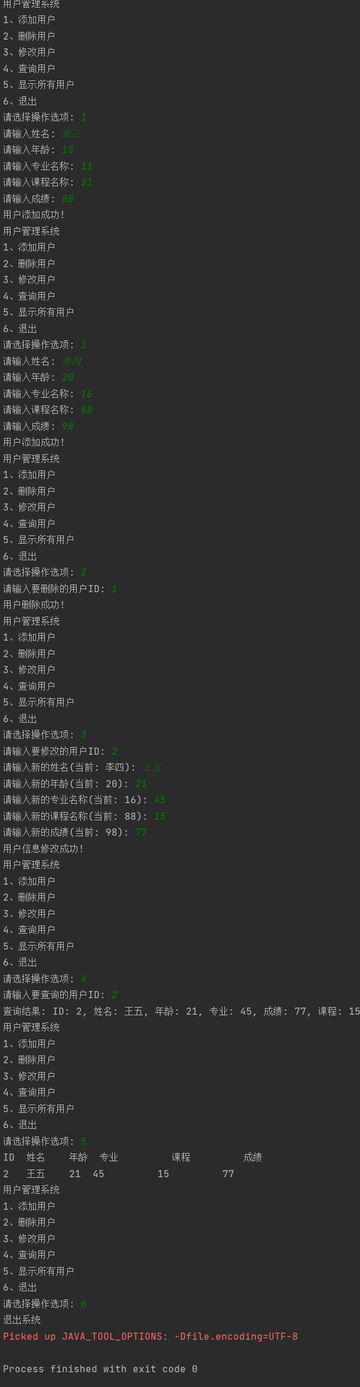

**兰天阳**

2024.8.18

类的构造函数没有返回值

this指代当前对象

无参构造为默认构造，但如果定义了有参构造，必须重新定义无参构造

get、set来取\定义属性值

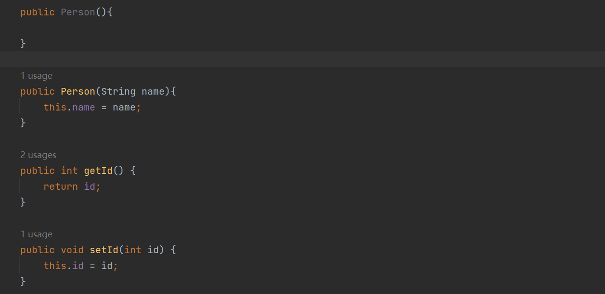

a==b比较的是数据在堆内的地址是否相同，而a.equals(b)比较的是数据是否相同

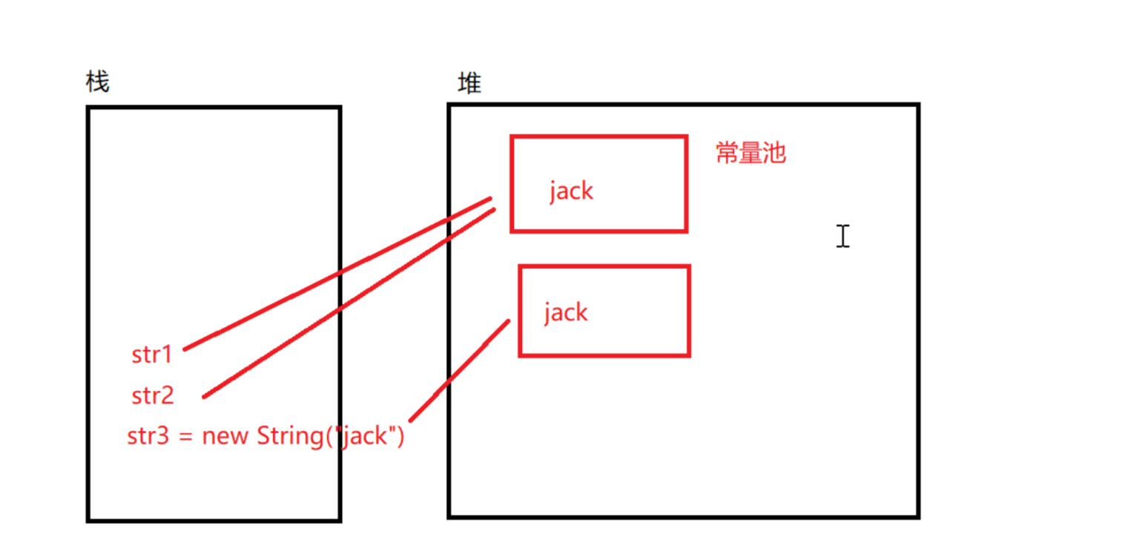

迭代器iterator使用方法：

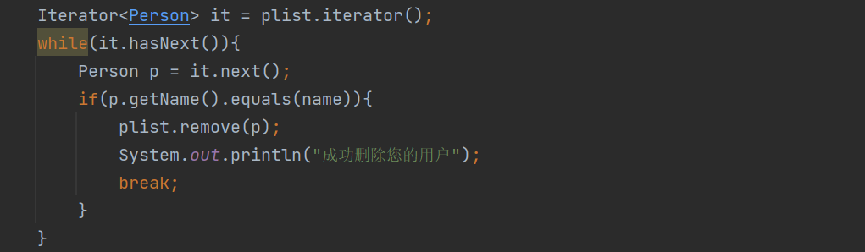

任务：

游戏

package cd;

import java.util.Random;

import java.util.Scanner;

public class Day4_1 {

public static void guess_number(int coin_num) {

Random rand = new Random();

int num = rand.nextInt(+100) + 1;

int min = 0;

int max = 100;

Scanner s1 = new Scanner(System.in);

Scanner s2 = new Scanner(System.in);

System.out.println("请在1-100中说出一个数,每猜一次数将会消耗一枚金币");

int count = 0;

while (true){

if(coin_num <= 0) {

System.out.println("金币不足！");

return;

}

int g = s1.nextInt();

if(g < num){

System.out.println("猜小了！");

min = g;

coin_num--;

count++;

System.out.println("当前剩余金币："+coin_num);

System.out.println("请在"+ min + "-" + max +"中说出一个数,每猜一次数将会消耗一枚金币");

}

if(g > num){

System.out.println("猜大了！");

max = g;

coin_num--;

count++;

System.out.println("当前剩余金币："+coin_num);

System.out.println("请在"+ min + "-" + max +"中说出一个数,每猜一次数将会消耗一枚金币");

}

if(g == num){

count++;

coin_num--;

if(count == 1){

System.out.println("Bingo!一次猜中！");

coin_num += 10;

}else{

System.out.println("猜对了！");

coin_num += 5;

}

System.out.println("当前剩余金币："+coin_num);

System.out.println("还要继续吗？1：继续 2：退出");

int c = s2.nextInt();

if(c == 1){

guess_number(coin_num);

}

if(c == 2){

return;

}

}

}

}

public static void big_or_small(int coin_num) {

Random rand1 = new Random();

int num1 = rand1.nextInt(6) + 1;

Random rand2 = new Random();

int num2 = rand2.nextInt(6) + 1;

Random rand3 = new Random();

int num3 = rand3.nextInt(6) + 1;

int sum = num1 + num2 + num3;

System.out.println("大还是小？每次两金币");

Scanner s1 = new Scanner(System.in);

while(true){

if(coin_num <= 0) {

System.out.println("金币不足！");

return;

}

String g = s1.nextLine();

coin_num -= 2;

if(g.equals("大")){

if(sum <= 10){

System.out.println("猜错了！你还剩" + coin_num + "金币");

}

if(sum >= 11){

coin_num += 5;

System.out.println("猜对了！奖励5金币，你还剩" + coin_num + "金币");

}

System.out.println("还要继续吗？1：继续 2：退出");

int c = s1.nextInt();

if(c == 1){

big_or_small(coin_num);

}

if(c == 2){

return;

}

}

if(g.equals("小")){

if(sum >= 11){

System.out.println("猜错了！你还剩" + coin_num + "金币");

}

if(sum <= 10){

coin_num += 5;

System.out.println("猜对了！奖励5金币，你还剩" + coin_num + "金币");

}

System.out.println("还要继续吗？1：继续 2：退出");

int c = s1.nextInt();

if(c == 1){

big_or_small(coin_num);

}

if(c == 2){

return;

}

}

}

}

public static void main(String[] args) {

int gold_coin = 5;

System.out.println("欢迎来到皇家赌场");

System.out.println("请选择你想玩的游戏：");

System.out.println("1:猜数字");

System.out.println("2:押大押小");

System.out.println("3:退出");

Scanner scan = new Scanner(System.in);

int choice = scan.nextInt();

if(choice == 1){

guess_number(gold_coin);

} else if(choice == 2){

big_or_small(gold_coin);

} else if (choice == 3) {

return;

}

}

}

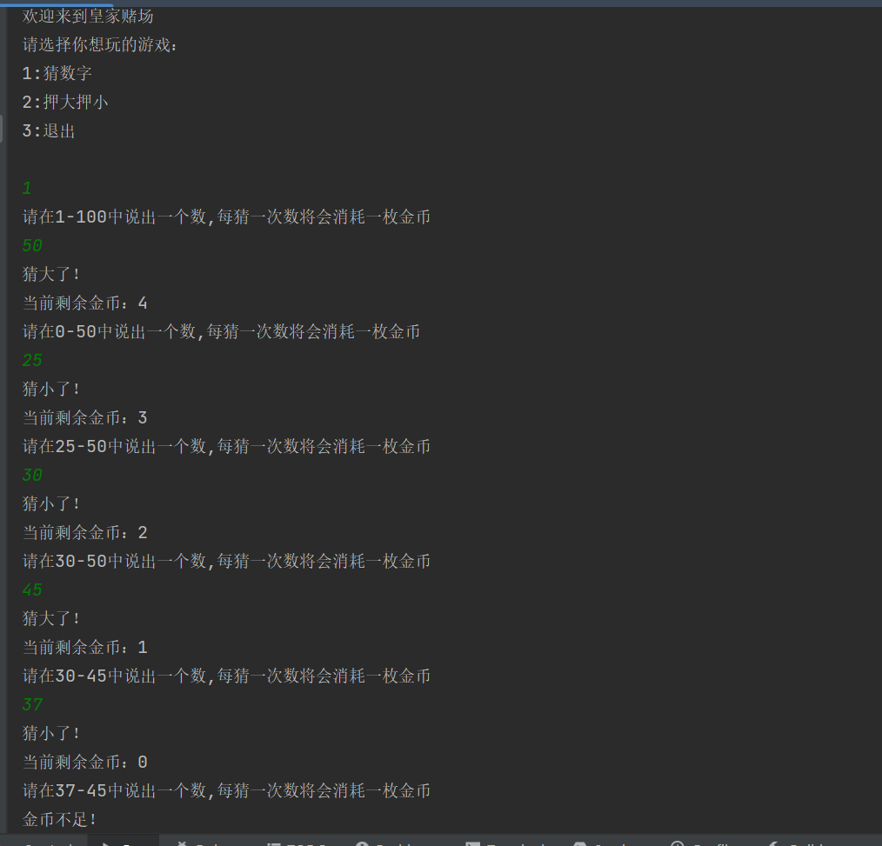

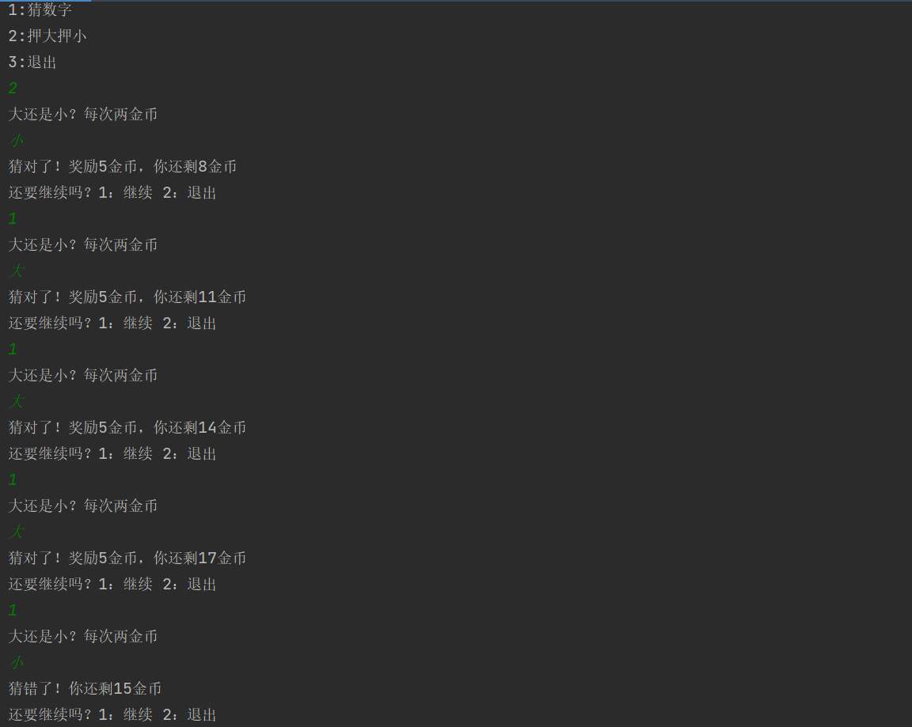

用户管理系统

package cd;

import java.util.ArrayList;

import java.util.Iterator;

import java.util.Scanner;

public class Day4_2 {

public static void add_ad(ArrayList<Person> plist){

System.out.println("请输入姓名：");

Scanner s = new Scanner(System.in);

String name = s.nextLine();

Person person = new Person(name);

System.out.println("亲爱的" + person.getName() + ",已为您创建用户");

plist.add(person);

person.setId(plist.indexOf(person)+1);

}

public static void delete_ad(ArrayList<Person> plist){

System.out.println("请输入姓名：");

Scanner s = new Scanner(System.in);

String name = s.nextLine();

Iterator<Person> it = plist.iterator();

while(it.hasNext()){

Person p = it.next();

if(p.getName().equals(name)){

plist.remove(p);

System.out.println("成功删除您的用户");

break;

}

}

}

public static void modify_ad(ArrayList<Person> plist){

System.out.println("请输入姓名：");

Scanner s = new Scanner(System.in);

String name = s.nextLine();

Iterator<Person> it = plist.iterator();

while(it.hasNext()){

Person p = it.next();

if(p.getName().equals(name)){

System.out.println("请选择要修改的数据:");

System.out.println("1:姓名");

System.out.println("2:年龄");

System.out.println("3:专业");

System.out.println("4:课程");

System.out.println("5:成绩");

int c = s.nextInt();

switch (c) {

case 1: {

System.out.println("请输入修改后的姓名:");

Scanner s1 = new Scanner(System.in);

String modified_name = s1.nextLine();

p.setName(modified_name);

break;

}

case 2: {

System.out.println("请输入修改后的年龄:");

Scanner s1 = new Scanner(System.in);

int modified_age = s1.nextInt();

p.setAge(modified_age);

break;

}

case 3: {

System.out.println("请输入修改后的专业:");

Scanner s1 = new Scanner(System.in);

String modified_major = s1.nextLine();

p.setMajor(modified_major);

break;

}

case 4: {

System.out.println("请输入修改后的课程名:");

Scanner s1 = new Scanner(System.in);

String modified_lessons = s1.nextLine();

p.setLessons(modified_lessons);

break;

}

case 5: {

System.out.println("请输入修改后的成绩:");

Scanner s1 = new Scanner(System.in);

int modified_scores = s1.nextInt();

p.setScores(modified_scores);

break;

}

default:{

break;

}

}

System.out.println("是否继续修改？");

System.out.println("1:是");

System.out.println("2:否");

int c1 = s.nextInt();

if(c1 == 1){

modify_ad(plist);

}else if(c1 == 2){

break;

}

}

}

}

public static void inquire_ad(ArrayList<Person> plist){

System.out.println("请输入姓名：");

Scanner s = new Scanner(System.in);

String name = s.nextLine();

Iterator<Person> it = plist.iterator();

System.out.println("id\t姓名\t年龄\t专业\t课程\t成绩");

while(it.hasNext()){

Person p = it.next();

if(p.getName().equals(name)){

System.out.print(p.getId() + " ");

System.out.print(p.getName() + " ");

System.out.print(p.getAge() + " ");

System.out.print(p.getMajor() + " ");

System.out.print(p.getLessons() + " ");

System.out.println(p.getScores());

}

}

}

public static void show_all(ArrayList<Person> plist){

Iterator<Person> it = plist.iterator();

System.out.println("id 姓名 年龄 专业 课程 成绩");

while(it.hasNext()){

Person p = it.next();

System.out.print(p.getId() + " ");

System.out.print(p.getName() + " ");

System.out.print(p.getAge() + " ");

System.out.print(p.getMajor() + " ");

System.out.print(p.getLessons() + " ");

System.out.println(p.getScores());

}

}

public static void main(String[] args) {

ArrayList<Person> plist = new ArrayList<>();

Scanner s1 = new Scanner(System.in);

while(true){

System.out.println("请选择操作选项：");

System.out.println("1:创建用户");

System.out.println("2:删除用户");

System.out.println("3:修改数据");

System.out.println("4:查询用户");

System.out.println("5:显示所有");

System.out.println("6:退出");

int c = s1.nextInt();

switch (c) {

case 1: {

add_ad(plist);

break;

}

case 2: {

delete_ad(plist);

break;

}

case 3: {

modify_ad(plist);

break;

}

case 4: {

inquire_ad(plist);

break;

}

case 5: {

show_all(plist);

break;

}

case 6: {

return;

}

default:{

break;

}

}

}

}

}

